AE 4341  
  
  
  
**Project** **4**: **Aircraft Sizing – Supersonic Transport**

April 28, 2022  
  
By: **Charles Evans, Grace Krahn, Alexander Liberman, Juan Jose Paez Chaves, and Eric Qiu**  
Instructors: Neil Weston & Carl Johnson

I certify that I have abided by the honor code of the Georgia Institute of Technology and followed the guidelines as specified by the project description of this assignment.

Table of Contents

Introduction and Market Analysis 6

Configuration Selection 8

Aircraft Weight Sizing Analysis 16

Drag Polar Analysis 25

Constraint Analysis 28

Trade Studies 32

Operating Capabilities 37

Wing Design 39

Materials Selection & Structural Layout 41

Moments of Inertia and Center of Gravity Analysis 45

Stability Analysis & Control Surface Sizing 53

Propulsion System 59

Cabin Layout 60

Cost Analysis 61

Concluding Remarks 64

Works Cited 65

# List of Figures

Figure 1. Potential routes for deployment of designed aircraft. 7

Figure 2. Final configuration of Project Morpheus aircraft. 15

Figure 3. Complete standard mission profile per RFP requirements for standard mission for Project Morpheus aircraft. 17

Figure 4. Complete alternate mission profile per RFP requirements for standard mission for Project Morpheus aircraft. 17

Figure 5. Weight regression plot for 12 selected aircraft. 19

Figure 6. Drag polar plot for supersonic cruise segment of mission profile at Mach 2 and 55,000 ft above sea level for Project Morpheus aircraft. 26

Figure 7. Drag polar plot for subsonic cruise segment of mission profile at Mach 0.95 and 35,000 ft above sea level for Project Morpheus aircraft. 27

Figure 8. Constraint sizing allowable design space for standard and alternate missions for Project Morpheus aircraft. 31

Figure 9. Trade study for takeoff weight sensitivity base on passenger capacity for Project Morpheus aircraft. 32

Figure 10. Trade study for takeoff weight sensitivity based on supersonic cruise range for Project Morpheus aircraft. 33

Figure 11. Trade study for constraint design space sensitivity based on takeoff field length for Project Morpheus aircraft. 34

Figure 12. Trade study for takeoff weight sensitivity-based variation of supersonic cruise Mach number and altitude for Project Morpheus aircraft. 35

Figure 13. Wave drag as a function of cruise Mach number for Project Morpheus aircraft 36

Figure 14. Trade study on vehicle takeoff weight as a function of technology factor for Project Morpheus aircraft 36

Figure 15. Designed flight envelope. 37

Figure 16: V-n diagram for the Project Morpheus aircraft. 38

Figure 17: Wing Root Airfoil Profile 39

Figure 18: Wing Tip Airfoil Profile 39

Figure 19. Project Morpheus Wing Planform 40

Figure 20. Wing structural layout for Project Morpheus aircraft. 42

Figure 21. Tail structural layout for Project Morpheus aircraft. 42

Figure 22. Fuselage structural layout for Project Morpheus aircraft. 43

Figure 23. Cross-sectional view of Project Morpheus Aircraft. 43

Figure 24. Primus Epic integrated flight deck on a long-range business jet. 44

[Figure 25. Vehicle center of gravity visualization 48](https://gtvault-my.sharepoint.com/personal/aliberman7_gatech_edu/Documents/AE%204341%20Project%204/Project%204%20Report.docx#_Toc102056804)

Figure 26: Overall geometry and three-view of Project Morpheus aircraft with most aft CG 49

Figure 27: CG Excursions for Mach 0.95(left) and Mach 2(right) 51

Figure 28. Numerical determination of subsonic cruise $Cm,α$ for Project Morpheus aircraft. 54

Figure 29. Numerical determination of supersonic cruise $Cm,α$ for Project Morpheus aircraft. 55

Figure 30. Numerical determination of subsonic cruise $Cn,β$ and $Cl,β$ for Project Morpheus aircraft. 56

Figure 31. Numerical determination of supersonic cruise $Cn,β$ and $Cl,β$ for Project Morpheus aircraft. 56

Figure 32. Wing control surfaces for Project Morpheus Aircraft. 57

Figure 33. Vertical tail control surface for Project Morpheus aircraft. 58

Figure 34. Proposed cabin layout. 60

Figure 35. Relationship between unit cost and aircraft produced (no engines included). 63

# List of Tables

Table I. Weighted Pugh matrix for wing shape selection. 12

Table II. Weighted Pugh matrix for engine location selection. 13

Table III. Weighted Pugh matrix for tail type selection. 13

Table IV. Weighted Pugh matrix for fuselage selection. 14

Table V. Weighted Pugh matrix for landing gear layout selection. 15

Table VI. Aircraft used for weight regression. 18

Table VII. Alternate mission climb segment details. 21

Table VIII. Alternate mission slow cruise segments 1 and 2 details. 21

Table IX. Alternate mission supersonic cruise segment details. 22

Table X. Alternate mission reserve cruise segment details. 22

Table XI. Alternate mission loiter segment details. 23

Table XII. Final segment and mission fuel fractions for alternate mission for Project Morpheus aircraft. 23

Table XIII. Final converged takeoff weight results for Project Morpheus aircraft. 24

Table XIV. Drag component values and corrections 27

Table XV: Wing Airfoil Characteristics at Tip and Root 39

Table XVI: Project Morpheus Wing Planform Characteristics 40

Table XVII. Radii of gyration calculation for NAA A3J-1 (). 45

Table XVIII. Static stability derivatives for Project Morpheus aircraft. 57

Table XIX. Hourly labor rates used in cost analysis for Project Morpheus aircraft. 61

# Introduction and Market Analysis

The first commercial supersonic transport jet, the Concorde, made its maiden flight on March 2, 1969. The Concorde continued to remain in service for Air France and British Airways for several decades but, in 2003, it flew its last commercial flight. Since then, no other aircraft manufacturer has attempted to introduce a new supersonic transport (SST) into service. However, with new technologies emerging in the aerospace sector, there has been a renewed interest in developing an SST.

Business passengers and high net worth individuals are less sensitive to high ticket prices than everyday consumers. Therefore, the time savings that would arise because of flying faster would present an advantage over more traditional transonic travel. Project Morpheus, the aircraft developed from this request for proposal (RFP), seeks to deliver supersonic travel to an all-business class passenger cabin with an entry into service (EIS) date of 2030.

A market analysis was further performed to determine the viability of an additional supersonic jet transport aircraft in today’s aviation market. In the past, there have been significant flaws in the manufacturing and efficiency of supersonic transports like the Concorde and the Tupolev Tu-144 (Witt). Project Morpheus seeks to make use of near-term technology and improvements in engine performance to redefine how supersonic airliners can operate, presenting an alluring business opportunity to airlines around the world. The Project Morpheus aircraft aims to compete on some of the most popular transoceanic routes in the world, trans-Atlantic flights, but with the unique selling point of supersonic travel (Sattler). Trans-Pacific routes are a market that could be targeted in later revisions of the aircraft but are not possible with the ranges targeted in this initial analysis.

The 2020 supersonic jet market size in North America was found to be worth $8.93 billion USD, growing from $8.87 billion in 2019. This market is only expected to grow exponentially, reaching $35.62 billion by 2030 (Fortune Business Insights). Similar aircraft in this category have already gathered $6 billion worth of pre-orders from companies around the world, including established airlines like the Virgin Group and Japan Airlines (Sillers). Though current regulations prohibit supersonic flight above landmasses, some of the most lucrative routes in the world are over oceans and other large bodies of water. Figure 1. Potential routes for deployment of designed aircraft. shows routes where the aircraft is expected to excel. This is where Project Morpheus will prove attractive to airline operators, allowing business travelers to fly transoceanic routes faster than any aircraft in the market today.

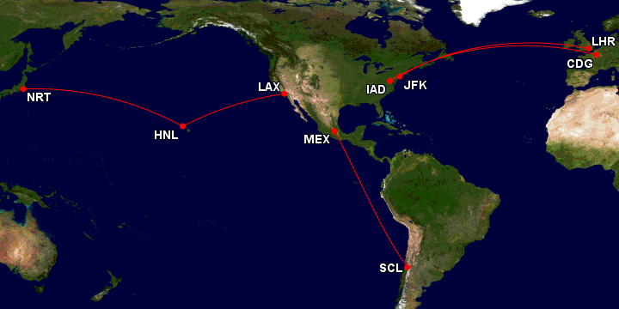

Figure 1. Potential routes for deployment of designed aircraft.

# Configuration Selection

To satisfy the RFP for this aircraft, a configuration needed to be selected for the Project Morpheus aircraft. A qualitative systematic approach was taken to arrive at the best configuration for the aircraft. Weighted Pugh matrices were used to evaluate the following configuration parameters for the aircraft: wing shape; engine location; tail type; body type; and landing gear configuration. To do so, the first step was to define the stakeholders for the SST.

The first and most important stakeholders for the project are the customer airlines. Project Morpheus needed to be developed to suit operators’ needs and provide economic operation over the aircraft’s lifespan. One of the reasons that a past innovator in the realm of SST aircraft, the Concorde, failed as a business model was that its steep development costs meant it was never able to fully overcome to make the aircraft profitable for the airlines to run (Curley). Development costs cover all costs related to the research, development, implementation, and testing that would be required to develop and certify the aircraft for operation. However, the target market for the Project Morpheus aircraft is solely business class, where people are more interested in getting to a destination quicker rather than doing so cheaply. Because of this, a higher ticket price per passenger due to development costs is not weighted as highly in the Pugh matrices as other costs, especially those related to maintainability.

A key factor at play in the cost that the airlines see to use a jet is aircraft aerodynamic efficiency. Aircraft manufactures will spend millions of dollars on projects aiming to increase aircraft efficiency by 1% or other similarly small improvements. However, the reason is that the combined costs of fuel per mile for a fleet of aircraft can result in savings of much more than this upfront investment as the aircraft are used for longer and more are produced (economy of scale). Project Morpheus will be designed for efficiency at its supersonic cruising speed, so configurations that on a conceptual level will have lower drag at these speeds will be more advantageous. Examples of this metric in action include selecting structurally strong wing configurations that can stay inside the Mach cone and choosing a fuselage cross-section that keeps wave drag as low as possible while still fulfilling its passenger-ferrying role.

Another important metric for the cost to airlines is vehicle maintenance costs, which includes regular vehicle inspection costs as well as the average cost to operate the aircraft and fill up the fuel tank. While the Concorde was never fully profitable due to high development costs, this did not prevent its operation on trans-Atlantic routes from 1976 through 2003. Factors that contributed to its retirement in 2003 also included the hike in fuel prices associated with the start of the Iraq War. The Concorde was a notorious fuel-guzzler compared to traditional subsonic airliners, a common factor among SST aircraft for which Project Morpheus is no exception. As such, operating costs likely shot up during the year which may have helped it along to retirement. With the shift toward renewables and sustainability in the recent decade, it will be important to choose an aircraft configuration that keeps these fuel costs low with an efficient and light design for the mission. Whether the aircraft are maintained by the airline, the manufacturer, or third-party maintenance providers, overhauls and inspections can add large costs to an aircraft over its operational lifespan. Consequently, maintenance crews were chosen as a stakeholder for the Project Morpheus SST. The FOM that reflected this stakeholder in the configuration selection was thus chosen as maintainability.

The third stakeholder of the program was the manufacturer itself. Reducing production costs for the aircraft can not only increase the profit margin on each unit, but also allow the aircraft to be offered at a lower cost to airlines, potentially increasing the size of the market for the program. These production costs were reduced to two FOMs: development costs, which were already discussed previously, and manufacturing costs. Manufacturing costs were further reduced to manufacturing simplicity to also account for possible sources of error that could occur due to the assembly process. Designs that feature hard-to-manufacture geometries and complex assemblies will be penalized under this FOM.

The aircraft pilots were another stakeholder considered in the selection of FOMs. The difficulty of flying the aircraft – and thus the safety of the passengers and crew – can be increased by designing redundant control schemes in case of system failure. An example of this would be the inclusion of a canard and tail to assist with maneuvering and provide redundancy in case of system failure. Some aircraft configurations have strict geometric and aerodynamic limitations on where certain control systems can be placed. The placement of high lift devices can be limited by the required size of the primary control surfaces like ailerons, elevators, and rudders and the geometric constraints of the wing, such as with a delta wing without a horizontal stabilizer. For such a configuration, flaps may not be possible because of the flow separation at the trailing edge for high angles of attack during takeoff and landing; perhaps less efficient leading-edge devices like slats would have to be used instead. Control schemes with less redundancies would inherently be less safe for the passengers and crew because there are fewer backups if a bird strike or some other fault occurs in the system. In addition, coupled controls like elevons or ruddervators would be less desirable from a pilot’s perspective because they’re less intuitive to fly and may take more training to master. All of these are considered as a part of the control schemes FOM, which is included to represent safety of passengers and crew, ease of training, and control surface/layout preferences of airline pilots.

The aerodynamic stability of a vehicle is also an important design aspect to consider with regard to its effects on the pilot stakeholders. The geometric design and layout of key features like the wings and tail should contribute to the overall stability of the aircraft. One of the key metrics for this is the longitudinal stability of the aircraft, which depends on the neutral point of the lifting body (the wing) and the center of gravity of the aircraft. While longitudinal stability isn’t inherently good or bad on its own, it certainly influences the handling characteristics of an aircraft. An unstable aircraft like a fighter jet will require the intervention of an advanced control system on the flight computer, which would make it much different from most modern airlines and would likely require extensive training. Pilots may have difficulties in forcing a highly stable aircraft to go to the necessary angle of attack for takeoff and landing. Therefore, the desired range is usually in the middle: around a 3-5% positive static stability margin. Roll and yaw stability is generally good to have and should be supported by the overall configuration geometry if possible. The stability FOM is an evaluation of the relative contributions of features to overall aircraft stability and is included to represent desired handling characteristics for pilot and passenger interest groups.

Passengers are an important stakeholder for this analysis but were not included directly in the form of comfort or experience in the preliminary configuration selection as an FOM. Since the Project Morpheus aircraft would be sold in an empty configuration, it is up to the individual airlines to define and implement cabin layouts to maximize passenger comfort. Therefore, the only parameters controllable by the manufacturer that would affect passengers are smaller ones such as noise and pressurization. These parameters are also largely determined by the aircraft’s supersonic requirements, so these were not chosen as FOMs. Thus, the six FOMs chosen were development cost, maintainability, supersonic performance, stability, control flexibility, and manufacturing simplicity.

These FOMs were applied to a weighted Pugh matrix to qualitatively define the best layout for the Project Morpheus aircraft. Since the airlines were the most important stakeholders for the project, operational efficiency and maintenance costs carried the largest weight in the Pugh matrix. Supersonic performance and maintainability had weights corresponding to 0.3, the highest rated FOMs. The development cost and manufacturing simplicity was chosen to be equally important FOMs, with an assigned weight of 0.1 in the Pugh matrix. Due to the EIS date of 2030, only near-term and current technologies were considered, lowering research and development costs for new technologies. Therefore, a lower weight for this FOM was considered than for maintainability and supersonic performance. Finally, the stability and control scheme FOMs were also assigned a weight of 0.1 to represent the pilot stakeholder groups. Different configurations of each aircraft parameter were considered and ranked from 1 to 4 with respect to each FOM to arrive at the best layout for each. In this case, a higher ranking denoted better performance in that FOM.

The first aircraft parameter to be evaluated was the wing shape, as can be seen in

Table I below. Four different configurations were considered with supersonic performance in mind: a highly swept wing with a Yehudi, an ogival delta wing, a double delta wing, and a trapezoidal wing with a front canard to handle pitch control. Ultimately, a double delta wing was chosen due to its efficiency at supersonic speeds, manufacturing simplicity, and high structural integrity that doesn’t compromise the thinness of the wing. This wing form provides additional space for landing gear and fuel storage and increases the structural rigidity of the wing through a large root chord over other options like the highly swept wing with Yehudi. The double delta wing generates vortex lift at high angles of attack during takeoff and landing just like the ogival delta; however, a double delta is less expensive to manufacture and maintain than the ogival delta due to the latter’s complex leading-edge curve. It also does not have as high a wing loading or the mechanical complexity that a trapezoidal wing with a front canard would. The development and maintenance cost penalties for the trapezoidal and highly swept wing configurations make them a non-ideal choice. Therefore, the double delta emerged as the best configuration for the aircraft.

Table I. Weighted Pugh matrix for wing shape selection.

|  |  |  |  |  |  |
| --- | --- | --- | --- | --- | --- |
| Figure of Merit | Value | Highly Swept Wing with Yehudi | Ogival Delta | Double Delta | Trapezoidal Wing with Front Canard |
| Stability | 0.1 | 3 | 2 | 2 | 2 |
| Control Scheme | 0.1 | 2 | 2 | 2 | 3 |
| Development Cost | 0.1 | 2 | 3 | 3 | 2 |
| Maintainability | 0.3 | 2 | 3 | 3 | 1 |
| Manufacturing Simplicity | 0.1 | 4 | 2 | 4 | 1 |
| Supersonic Performance | 0.3 | 2 | 3 | 3 | 1 |
| Total | 1.0 | 2.3 | 2.7 | 2.9 | 1.4 |

The engine location followed from the determination of the number of engines. This is seen in

Table II below. Engines were considered under the wing, above and below the wing, and mounted on the tail. Under-wing engines streamlined with the body were selected for the aircraft’s engine location, as these were determined to have the least aerodynamic impact while minimizing maintenance and development costs. Engines above and below the wing would have greatly complicated maintenance and increased development costs for the aircraft. Likewise, exclusively tail-mounted engines would have added more maintenance concerns and presented aerodynamic problems with supersonic airflow that would have made them unfavorable for the aircraft. Since multiple engines would likely be needed for the aircraft, having all of them in the tail would also increase structural loads in the tail section of the aircraft and move the center of gravity further aft, which could hurt the elevator control authority and decrease pitch stability. Thus, engines below the wing were chosen. The number of engines were determined via a constraint sizing analysis performed later in the development of the aircraft.

Table II. Weighted Pugh matrix for engine location selection.

|  |  |  |  |  |
| --- | --- | --- | --- | --- |
| Figure of Merit | Value | Below Wing | Above and Below Wing | Tail-Mounted |
| Stability | 0.1 | 2 | 2 | 2 |
| Control Flexibility | 0.1 | 2 | 2 | 2 |
| Development Cost | 0.1 | 4 | 3 | 2 |
| Maintainability | 0.3 | 3 | 2 | 2 |
| Manufacturing Simplicity | 0.1 | 3 | 3 | 3 |
| Supersonic Performance | 0.3 | 3 | 2 | 1 |
| Total | 1.0 | 2.9 | 2.2 | 1.8 |

The next parameter to be evaluated was the tail type, as seen in Table III below. The chosen configurations included a T-tail, a single vertical tail, and a split-V tail. The single vertical tail was selected as the design choice. It featured a lower overall weight and easier maintainability than the others, so it was ultimately the best choice. A T-tail was ruled out due to the aerodynamic and structural complications of flight controls so far from the center of gravity. The split-V tailed was considered aerodynamically effective but was deemed too difficult to maintain for airline operators. It would also further complicate the aircraft’s controls, taking away from the manufacturing simplicity and adding unnecessary development time and cost.

Table III. Weighted Pugh matrix for tail type selection.

|  |  |  |  |  |  |
| --- | --- | --- | --- | --- | --- |
| Figure of Merit | Value | T-Tail | Conventional Tail | Split V Tail | Single Vertical Tail |
| Stability | 0.1 | 3 | 3 | 3 | 1 |
| Control Flexibility | 0.1 | 2 | 3 | 2 | 1 |
| Development Cost | 0.1 | 1 | 2 | 3 | 4 |
| Maintainability | 0.3 | 1 | 3 | 2 | 4 |
| Manufacturing Simplicity | 0.1 | 1 | 3 | 2 | 4 |
| Supersonic Performance | 0.3 | 1 | 3 | 2 | 4 |
| Total | 1.0 | 1.3 | 2.9 | 2.2 | 3.4 |

The fuselage type selection matrix can be seen in Table IV below. Three fuselage types were evaluated: a standard narrowbody layout, a widebody configuration, and a blended wing fuselage. While the blended wing body could increase payload weight due to the lower overall aircraft weight, the expected difficulties developing, maintaining, and manufacturing the aircraft greatly outweighed the benefits. The blended wing configuration would reduce the wing’s wetted area and thus improve aerodynamics, but structural complications along with the reduced cabin size make this design unfavorable. A widebody fuselage was ruled out because the greater cross-sectional area would harshly affect the aerodynamic efficiency at supersonic speeds due to the increased wave drag. While this configuration would create additional space for passengers and cargo, this would come at severe weight, maintainability, and development cost penalties. Therefore, a standard narrowbody fuselage was selected due to its simplicity, relatively small cross-section, cost-effectiveness, and expected reliability.

Table IV. Weighted Pugh matrix for fuselage selection.

|  |  |  |  |  |
| --- | --- | --- | --- | --- |
| Figure of Merit | Value | Standard | Blended Wing | Wide |
| Stability | 0.1 | 2 | 2 | 2 |
| Control Flexibility | 0.1 | 2 | 2 | 2 |
| Development Cost | 0.1 | 3 | 2 | 2 |
| Maintainability | 0.3 | 3 | 1 | 2 |
| Manufacturing Simplicity | 0.1 | 3 | 1 | 2 |
| Supersonic Performance | 0.3 | 2 | 4 | 1 |
| Total | 1.0 | 2.5 | 2.2 | 1.7 |

Finally, the landing gear selection was carried out in Table V. Weighted Pugh matrix for landing gear layout selection. below. The three main types of landing were evaluated: a standard trike layout, a tail dragger layout, and a tandem gear configuration. The tail dragger featured good maintainability and simplicity but was ruled out due to the increased development cost needed to ensure that the aircraft could take off and land at the necessary angles of attack. Likewise, the tandem gear configuration could have saved weight but would have resulted in a greater development penalty. Furthermore, tandem gear layouts are not often used for passenger aircraft, and as such the manufacturing process would not be as robust as that of more traditional landing gear. Thus, the traditional trike layout was selected, with a double-bogey design in the main gear to be able to better carry the structural loads of the aircraft on the ground.

Table V. Weighted Pugh matrix for landing gear layout selection.

|  |  |  |  |  |
| --- | --- | --- | --- | --- |
| Figure of Merit | Weight | Trike | Tail Dragger | Tandem |
| Stability | 0.1 | 2 | 2 | 2 |
| Control Flexibility | 0.1 | 4 | 1 | 2 |
| Development Cost | 0.1 | 4 | 1 | 2 |
| Maintainability | 0.3 | 4 | 3 | 2 |
| Manufacturing Simplicity | 0.1 | 4 | 3 | 2 |
| Supersonic Performance | 0.3 | 2 | 2 | 2 |
| Total | 1.0 | 3.2 | 2.2 | 2 |

Therefore, the aircraft was chosen to be a narrowbody with a double delta wing, single vertical tail, tricycle landing gear, and engine location below the wings. This selected configuration is what was used for all subsequent sizing and analysis. An image of this final configuration can be seen in Figure 2 below.

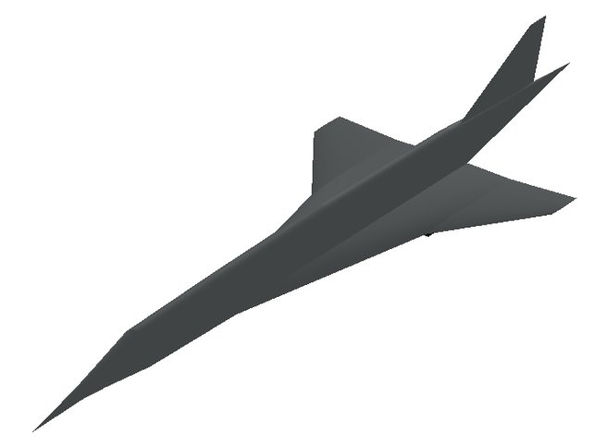

Figure 2. Final configuration of Project Morpheus aircraft.

# Aircraft Weight Sizing Analysis

Following the configuration selection, a preliminary weight sizing analysis could be performed on the Project Morpheus aircraft. The primary goal of the weight sizing was to arrive at a rough estimate for the maximum takeoff weight of the aircraft. Even though the aircraft would be sold with an empty cabin configuration, payload requirements with passengers and crew were considered. For the weight sizing analysis, an all-business cabin configuration with capacity for 50 passengers was considered. This number was chosen to align with the relatively small but high-paying market the aircraft targets. Additionally, it was assumed that 6 crew members would be required to operate the aircraft. Each passenger was assumed to weigh 200 lbs and carry 30 lbs of equipment on board.

The mission requirements for the Project Morpheus aircraft were split into two possible missions to account for the different cruise segment requirements stated in the RFP. The standard mission involved taking off and climbing to 50,000 ft per RFP requirements. This would later be changed to 55,000 ft in accordance with a sensitivity study performed in the Trade Studies section. After reaching the cruise elevation, the aircraft would cruise at Mach 2 for 4000 nm. This cruise speed was chosen since it resulted in the least amount of wave drag at 55,000 ft and aligned with engine information. Additionally, it would also allow the aircraft to fly more than twice as fast as traditional jet transports. Reserve requirements were incorporated into the mission profile in accordance with FAR Part 25 regulations (Federal Aviation Administration). These included a 200 nm reserve cruise segment and a 45-minute loiter, both assumed to be at 15,000 ft. The speed of the reserve cruise was 0.95 Mach, chosen because it was assumed that the reserve cruise and loiter would be over land. Therefore, the aircraft could not go beyond Mach 1. For the loiter segment, it was assumed that the aircraft was already close to the target airport, so the speed was set to 0.4 Mach. Following these segments, the aircraft was assumed to land normally. The mission profile can be seen in Figure 2 below. For both the standard and alternate missions, preliminary calculations were performed based on the same requirements as the RFP. After proper trade studies were performed and some requirements changed, the numbers were substituted instead of the original values. Therefore, all final calculations were done with the new requirements, resulting in the final sizing of the aircraft.

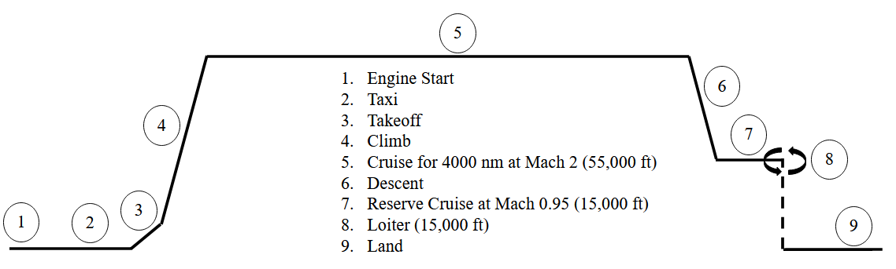

Figure 3. Complete standard mission profile per RFP requirements for standard mission for Project Morpheus aircraft.

The alternate mission began the same as the standard one. After takeoff, though, it climbed to 35,000 ft instead of 55,000. At this altitude, the aircraft began a slow cruise at Mach 0.95. The RFP requirements stated that the slow cruise needed to cover a range of 1000 nm, so this was split to 500 nm before and after supersonic cruise. This was done since the primary use case for the Project Morpheus aircraft is as a trans-oceanic transport, so it would need to fly more slowly until it was far away enough from land to fly at its supersonic cruise. Following the initial slow cruise segment, the aircraft could then cruise at Mach 2 as normal for 3000 nm. After cruise, the second slow cruise segment would occur for a range of 500 nm. Then, the aircraft would descend to 15,000 ft. As with the standard mission, reserve requirements were incorporated into this altitude, with a 200 nm reserve cruise and 45-minute loiter at 0.95 Mach and 0.4 Mach, respectively. Finally, the aircraft landed as normal. The alternate mission profile can be seen in Figure 4. Complete alternate mission profile per RFP requirements for standard mission for Project Morpheus aircraft. below.

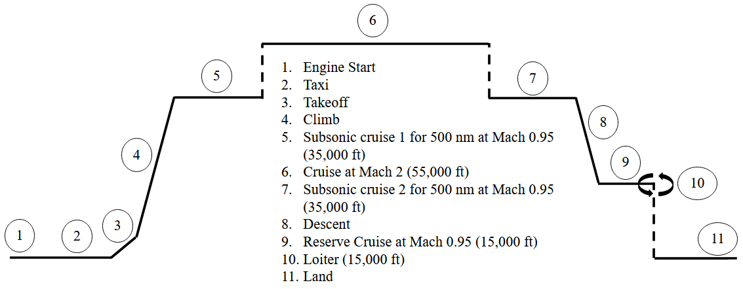

Figure 4. Complete alternate mission profile per RFP requirements for standard mission for Project Morpheus aircraft.

Since both mission profiles were clearly defined, the weight sizing analysis could begin. The first thing to do was to perform a weight regression on several types of aircraft to arrive at the regression constants $a$ and $b$, which would be used to estimate the allowable empty weight of the aircraft from a guess of the takeoff weight. This followed from (1, seen below. Here, $W_{E}$ was the empty weight of the aircraft and $W_{TO}$ was the maximum takeoff weight.

|  |  |  |
| --- | --- | --- |
| on 1 | $$\log_{10}{W_{E}}=\frac{\log_{10}{W_{TO}-a}}{b}$$ | (1) |

Since Equation 1 follows a logarithmic relationship, the regression constants could be determined from historical data by plotting the base-10 logarithm of the takeoff weight against the base-10 logarithm of the empty weight. The resulting constants from the linear regression of the plot could be used as $a$ and $b$. Overall, 12 total aircraft were evaluated to develop the regression plot as shown in Table VI. The regression constants were determined to be 0.03826 and 1.0599 for $a$ and $b$, respectively. The weight regression plot can be seen Figure 5 below. The first regression constant, $a$, was multiplied by constant $η$ for all weight sizing calculations. Here, $η$ is a constant accounting for advanced materials. Since the Project Morpheus aircraft would be built with near-term technology, this constant was assumed to be 0.95.

Table . Aircraft used for weight regression.

|  |  |  |  |  |
| --- | --- | --- | --- | --- |
| Aircraft | WTO (lbs) | WE (lbs) | log10WTO | log10WE |
| X-59 QueSST | 25000 | 14990 | 4.39794 | 4.1758 |
| Aerion SBJ | 90000 | 45100 | 4.95424 | 4.65418 |
| Spike S-512 | 115000 | 47250 | 5.0607 | 4.6744 |
| Concorde | 408000 | 173500 | 5.61066 | 5.2393 |
| Tu-144 | 456357 | 218699 | 5.6593 | 5.33985 |
| Sukhoi-Gulfstream S-21 | 114200 | 54167 | 5.05767 | 4.73373 |
| SAI Quiet Supersonic Business Jet | 153000 | 70000 | 5.18469 | 4.8451 |
| Hisac Project - delta wing | 102160 | 45215 | 5.00928 | 4.65528 |
| Hisac Project - sweptback wing | 98438 | 48444 | 4.99316 | 4.68524 |
| Boom Overture | 264555 | 132277 | 5.42252 | 5.12148 |
| Aerion AS-2 | 133000 | 57800 | 5.12385 | 4.76193 |
| Tupolev Tu-444 | 90389 | 42549 | 4.95612 | 4.62889 |
| HyperMach HyperStar | 183000 | 87000 | 5.26245 | 4.93952 |

Figure 5. Weight regression plot for 12 selected aircraft.

The weight sizing methodology used in this analysis involved matching the allowable empty weight estimate from Equation (1) to an empty weight estimate coming from Equation (2) below. The takeoff weight in this equation matched the one from Equation (1). Here, $W_{F}$ was the fuel weight of the aircraft; $W_{PL}$ was the payload weight, defined as the weight of the passengers and their equipment; $W_{crew}$ was the weight of the crew and their equipment; and $W_{TFO}$ was the weight of the trapped fuel and oil. The trapped fuel and oil weight fraction was assumed to be 0.005 in accordance with best practices (Roskam).

|  |  |  |
| --- | --- | --- |
| (2) | $$W_{E}=W_{TO}-W_{F}-W_{PL}-W_{crew}-W_{TFO}$$ | (2) |

Therefore, the only quantity in Equation (2) left to determine was the fuel weight. To calculate this weight, an estimate of the total mission fuel fraction, or $M_{ff}$, was needed. This was calculated by first determining the individual mission segment fuel fractions, or $M_{ff,i}$, and multiplying them together. The mission segments were defined from the same mission segments defined in Figure 3. Complete standard mission profile per RFP requirements for standard mission for Project Morpheus aircraft. and Figure 4. Complete alternate mission profile per RFP requirements for standard mission for Project Morpheus aircraft. The mission segment fuel fractions were determined from Equation (3) below.

|  |  |  |
| --- | --- | --- |
|  | $$M_{ff,i}=exp\left(\frac{-Rc_{j}}{V*L/D}\right)$$ | (3) |

In Equation (3), $R$ was the range of the mission segment; $c_{j}$ was the engine thrust-specific fuel consumption (TSFC); $V$ was the speed of the mission segment; and $L/D$ was the lift-to-drag ratio at the mission segment. The segment fuel fractions for the start, taxi, takeoff, descent, and landing segments for both missions were directly determined from historical trends and can be seen in Table XII (Roskam). Therefore, the only segment fuel fractions that needed to be determined for the mission profile were for the climb, cruise, reserve cruise, and loiter segments. As a result of prior analysis that determined the alternate mission profile to be more constraining and thus selected as the sizing mission, calculations were only conducted for the vehicle sizing following the alternate mission profile at this stage of the design process.

The fuel fraction for the climb segment required a slight modification for Equation (3). Endurance was substituted for range in the equation, eliminating the need for a climb velocity. The average climb rate for this segment was chosen to be about 1,530 fpm over a timeframe (endurance) of 36 minutes. The TSFC for all segments was calculated based on a method outlined by Buananno for supersonic transports (Buonnano). This method involves using segment Mach number, altitude, and percentage of total power as inputs. The TSFC was calculated for each segment at 100% power for simplicity. In addition to this method, a technology adjustment factor was of 0.9 was included to account for any propulsive efficiency gains that could occur throughout the development of the aircraft. Since near-term technology was to be used, it was assumed that there could be some efficiency gains due to technology between now and the expected EIS date of the aircraft, so all calculated TSFC values for the aircraft were multiplied by this TSFC adjustment. For the climb segment, this TSFC was found to be 0.76 lb/lb/hr. The lift-to-drag ratio for this segment was determined using the Class II drag polar methodology detailed in the Drag Polar section. The final value was found to be 5.59. Thus, the climb segment fuel fraction was 0.922. For a summary of the assumptions and values used for the climb segment, see Table VII below.

Table . Alternate mission climb segment details.

|  |  |  |  |  |  |  |
| --- | --- | --- | --- | --- | --- | --- |
|  | Altitude | Climb Rate | L/D | TSFC | Endurance | Fuel Fraction |
| Unit | Ft | fpm | ~ | lbs/lbs/hr | hr | ~ |
| Value | 35,000 | 972 | 5.59 | 0.760 | 0.6 | 0.922 |

Next, calculations were performed for both subsonic cruise segments and the supersonic cruise segment. Both subsonic cruise segments were calculated in the same way. Their range was set to 500 nm each in accordance with the RFP. For both cases, the speed of the aircraft corresponded to 0.95 Mach at 35,000 ft. Per standard atmospheric calculations, this resulted in a speed of 547 knots (U.S. Standard Atmosphere, 1976). Their TSFC was found to be 0.861 lb/lb/hr. Where the two quantities differed was in their lift-to-drag ratios as a consequence of lower vehicle weight during the second subsonic cruise segment from fuel burn. The first subsonic cruise segment had a lift-to-drag ratio of 8.69, while the second segment had one of 10.61. The segment fuel fractions for the first and second slow cruise segments were 0.913 and 0.929, respectively. See Table VIII below for a summary of the assumptions and values.

Table . Alternate mission slow cruise segments 1 and 2 details.

|  |  |  |  |  |  |  |  |  |
| --- | --- | --- | --- | --- | --- | --- | --- | --- |
|  | Altitude | Range | Cruise Mach | Speed of Sound | Velocity | L/D | TSFC | Fuel Fraction |
| Unit | Ft | nm | ~ | kts | kts | ~ | lbs/lbs/hr | ~ |
| Segment 1 | 35,000 | 500 | 0.95 | 576 | 548 | 8.69 | 0.861 | 0.913 |
| Segment 2 | 35,000 | 500 | 0.95 | 576 | 548 | 10.61 | 0.861 | 0.929 |

For the cruise segment of the alternate mission, the range was determined by the requirements in the RFP. This was 3,000 nm. The velocity was Mach 2, which at the altitude of 55,000 ft was equal to 1147 knots per standard atmospheric calculations (U.S. Standard Atmosphere, 1976). This elevation was initially chosen because the 50,000 ft requirement in the RFP resulted in extremely high weight values in preliminary analysis but was subsequently changed since it resulted in extremely high thrust loading values. At 55,000 ft above sea level, the speed of the aircraft did not change appreciably. The TSFC for the segment was determined using the same method as before with the technology adjustment factor of 0.9 as well. The final value for the cruise segment was 1.081 lb/lb/hr. Similarly, the lift-to-drag ratio was determined using the Class II drag polar analysis. The final value was determined to be 10.79. Therefore, the cruise segment fuel fraction was 0.769. See Table IX below for a summary of the assumptions and values.

Table . Alternate mission supersonic cruise segment details.

|  |  |  |  |  |  |  |  |  |
| --- | --- | --- | --- | --- | --- | --- | --- | --- |
|  | Altitude | Range | Cruise Mach | Speed of Sound | Velocity | L/D | TSFC | Fuel Fraction |
| Unit | ft | nm | ~ | kts | kts | ~ | lbs/lbs/hr | ~ |
| Value | 55,000 | 3000 | 2 | 574 | 1147 | 10.79 | 1.081 | 0.769 |

The reserve cruise segment was the next to be analyzed. Per the mission profile of the aircraft, this segment involved flying at 0.95 Mach at 15,000 ft. This resulted in a velocity of 595 knots per standard atmospheric calculations (U.S. Standard Atmosphere, 1976). The range was set to 200 nm. The TSFC and lift-to-drag ratio were determined to be 0.922 lb/lb/hr and 11.12, respectively, using the same methods as before. This resulted in a reserve segment fuel fraction of 0.973. For a summary of the assumptions and values used for the reserve cruise segment, see Table X below.

Table . Alternate mission reserve cruise segment details.

|  |  |  |  |  |  |  |  |  |
| --- | --- | --- | --- | --- | --- | --- | --- | --- |
|  | Altitude | Range | Cruise Mach | Speed of Sound | Velocity | L/D | TSFC | Fuel Fraction |
| Unit | ft | nm | ~ | kts | kts | ~ | lbs/lbs/hr | ~ |
| Value | 15,000 | 200 | 0.95 | 626 | 595 | 11.12 | 0.922 | 0.973 |

Finally, for the loiter segment, the endurance of 45 minutes could be used in place of a velocity and range using the same substitution made for the climb mission segment. The TSFC and lift-to-drag ratio were determined using the same methods as every other mission segment and had final values of 0.689 lb/lb/hr and 5.24, respectively. The final loiter segment fuel fraction was then calculated to be 0.906. See Table XI below for a summary of the assumptions and values.

Table . Alternate mission loiter segment details.

|  |  |  |  |  |  |
| --- | --- | --- | --- | --- | --- |
|  | Altitude | E | L/D | TSFC | Fuel Fraction |
| Unit | Ft | Hr | ~ | lbs/lbs/hr | ~ |
| Value | 15,000 | 0.75 | 5.24 | 0.689 | 0.906 |

The final values for all fuel fraction segments can be seen in Table XII below. The values in Table VI included all changes to requirements made as a result of the trade studies. The total mission fuel fraction for the mission was determined by multiplying the fuel fractions of each individual mission segment together. The resulting mission fuel fraction was found to be 0.508, which can be seen in Table XII below as well. Out of these, as expected, the cruise segment proved to require the most fuel. This made sense, as it is the longest segment and requires supersonic speeds, which requires significant fuel burn.

Table XII. Final segment and mission fuel fractions for alternate mission for Project Morpheus aircraft.

|  |  |  |
| --- | --- | --- |
| Segment Number | Segment Name | Fuel Fraction |
| 1 | Start | 0.990 |
| 2 | Taxi | 0.990 |
| 3 | Takeoff | 0.995 |
| 4 | Climb | 0.922 |
| 5 | Slow Cruise 1 | 0.913 |
| 6 | Cruise | 0.769 |
| 7 | Slow Cruise 2 | 0.929 |
| 8 | Descent | 0.990 |
| 9 | Reserve Cruise | 0.973 |
| 10 | Loiter | 0.906 |
| 11 | Land | 0.992 |
| Total: | Mff | 0.508 |

The weight of the fuel could then be estimated for the aircraft. Since the weight fraction for the trapped fuel and oil was assumed to be 0.005, this could be combined with the mission fuel fraction to arrive at a single fuel weight, seen in (4 below, where $W_{TO}$ was the takeoff weight guess matching all other equations.

|  |  |  |
| --- | --- | --- |
| (4) | $$W_{F}=\frac{(1-W_{TO})M_{ff,cruise}}{1-M_{ff,TFO}}$$ | (4) |

Different values for $W_{TO}$ were assumed until the empty weights resulting from Equation (1) and Equation (2) matched for the input lift-to-drag ratios as determined by the class II drag polar. Once sufficient iterations were conducted such that vehicle weight did not change appreciably between iterations, the vehicle size and weight were assumed to have converged. More detail on this process can be found in the drag polar section. Then, the guess for $W_{TO}$ was taken as the correct takeoff weight of the aircraft. The $W_{E}$ was also taken to be the correct empty weight of the aircraft. Final takeoff weight for the aircraft were determined to be 195,149 lbs. Details can be seen in Table XIII below.

Table XIII. Final converged takeoff weight results for Project Morpheus aircraft.

|  |  |  |  |  |
| --- | --- | --- | --- | --- |
| Value | Weight (lbs) | Advanced Materials Constant, $η$ | Adjusted Regression Coefficient, $a$ | Regression Coefficient, $b$ |
| Maximum Takeoff Weight | 195,150 | 0.95 | 0.06188 | 1.0599 |
| Fuel Weight | 96,556 |
| Empty Weight | 85,714 |
| Payload Weight  (Including crew) | 12,880 |

# 

# Drag Polar Analysis

Since the weight sizing calculations depended on the lift-to-drag ratios, these needed to be determined. This was done via a Class II drag polar analysis, achieved by modeling the aircraft in Vehicle Sketch Pad (VSP) and conducting aerodynamic analysis. For each mission segment, the lift-to-drag ratio of the aircraft was calculated as the ratio of the lift coefficient, $C_{L}$, to the drag coefficient, $C_{D}$ of the aircraft. The total drag coefficient of the aircraft can be broken down into three components: the zero-lift, or parasite, drag $C_{D,0}$, induced drag $C_{D,i}$, and wave drag $C_{D, wave}$. This is seen in (5 below.

|  |  |  |
| --- | --- | --- |
| (5) | $$C_{D}= C_{D,0}+C_{D,i}+C_{D, wave}$$ | (5) |

For both induced and parasite drag values, VSPaero was utilized to conduct an alpha sweep from which $C_{L}$, $C_{D,0}$ and $C_{D,i}$ values were calculated. For each mission segment, a desired $C_{L}$ value was determined by (6), with $ρ$ being the air density at the appropriate altitude, V is the airspeed and S is wing planform area. Since the wing loading is the ratio of weight to wing planform area, multiplying the converged $W_{TO}$ by the chosen wing loading yielded $S$. This appropriate parasite and induced drag components were then calculated through a linear interpolation of the resultant datapoints from the alpha sweep neighboring the desired $C_{L}$ value.

|  |  |  |
| --- | --- | --- |
| (6) | $$C_{L}=\frac{2W_{TO}}{ρV^{2}S}$$ | (6) |

The final drag component was the wave drag, which is present only under supersonic flight conditions, so it was set to 0 for all subsonic mission segments. This drag component is a significant component of total drag when present and is heavily dependent on the cross-sectional area distribution curve as a consequence of the area rule. The smoother the changes in cross sectional area of the aircraft, the lower total wave drag becomes. As such, the fuselage was designed with slight variation in the diameter to smooth out the area distribution and reduce wave drag.

For the takeoff/climb mission segment, an additional drag correction needed to be made for high lift devices and landing gear that are not present in the simulated clean condition. Typically, landing gear would account for a drag correction factor of .015 and flaps would account for a correction of .01 at a minimum (Roskam). As our aircraft is only using slats as high lift devices, which are not as significant to the overall drag as flaps, alongside the fact that landing gear is only exposed for the first part of the climb segment, the drag polar correction assumed for the takeoff/climb segment was .01. This correction alongside the correction for wave drag were added to the interpolated drag values for the appropriate mission segments, from which a total segment drag value was calculated.

Once both the lift and drag coefficients were determined, their ratio could be taken to produce a lift-to-drag ratio for the individual mission segments. From these values, the takeoff weight of the aircraft was then converged, resulting in an updated wing area, desired segment $C_{L}$ values, and mission fuel fractions. The model in VSP was changed to reflect the necessary changes and the process was repeated until a final weight and size were converged upon.

Once all $\frac{L}{D}$ values matched and a final takeoff weight was determined, a drag polar plot could be constructed for the supersonic and subsonic mission cruise segments. This was done by once again performing an alpha sweep at both the supersonic and subsonic cruise conditions and plotting the results. These can be seen in Figure 6 and Figure 7 below.

Figure 6. Drag polar plot for supersonic cruise segment of mission profile at Mach 2 and 55,000 ft above sea level for Project Morpheus aircraft.

Figure 7. Drag polar plot for subsonic cruise segment of mission profile at Mach 0.95 and 35,000 ft above sea level for Project Morpheus aircraft.

It is important to note that lift and drag coefficient calculations in VSP were performed only on the lifting surfaces, notably excluding the fuselage, due to issues the program has with incorporating the fuselage in the vortex lattice. Additionally, engine nacelles pose an issue to the program and were not accounted for in drag calculations, as the effect of these on drag was unknown. Thus, true vehicle weight would be somewhat higher than our listed values due to increased drag. Furthermore, parasite drag calculations for a zero-lift condition were conducted with the parasite drag analysis tool as opposed to using the vortex lattice method from the alpha sweep, which leads to a marginally different parasite drag values when calculating lift-to-drag ratios, but the result on vehicle weight is negligible. A table of all significant drag components can be found in Table XIV below.

Table XIV. Drag component values and corrections

|  |  |  |  |  |
| --- | --- | --- | --- | --- |
| Drag component | $C_{D,0}$ (supersonic cruise) | $C_{D,0}$ (supersonic cruise) | $C_{D, wave}$ (M=2) | Landing gear + slats correction |
| ~ | .00699 | .00671 | .0047 | .01 |

# Constraint Analysis

Following the weight sizing and drag polar analyses, a constraint analysis was carried out to more accurately size the Project Morpheus aircraft. The primary goal of the constraint analysis was to determine accurate wing loading and thrust loading values. The former was especially important since it directly affected drag calculations. For preliminary analysis, a wing loading was assumed, but it verified through the constraint analysis. The constraint analysis also determined the thrust required for the aircraft, dictating the number engines that would be needed to carry out missions.

As previously stated, the wing loading was defined as the ratio of maximum takeoff weight to wing planform area $S$. Thrust loading was defined as the ratio of sea level thrust, $T_{SL}$, to maximum takeoff weight. Seven different cases were considered to determine the wing and thrust loading allowed by the requirements stated in the RFP. These were: standard mission cruise; alternate mission cruise; the first and second slow cruise segments for the alternate mission; climb; takeoff; and final approach constraints. Constraint sizing was carried out using the energy-based approach seen in (7 below (Mattingly, Heiser and Daley).

|  |  |  |
| --- | --- | --- |
|  | $\frac{T_{SL}}{W_{TO}}=\frac{β}{α}\left[\frac{qS}{βW_{TO}}\left[K_{1}{\left(\frac{nβW_{TO}}{qS}\right)}^{2}+K_{2}\left(\frac{nβW_{TO}}{qS}\right)+C_{D,0}+\frac{R}{qS}\right]+\frac{1}{V}\frac{∂}{∂t}\left(h+\frac{V^{2}}{2g}\right)\right]$ | (7) |

Equation (7) was used to determine the thrust loading of the aircraft at a given case and wing loading. The constraint analysis was conducted by choosing arbitrary values for the wing loading and calculate the thrust loading for each. After doing this for all seven cases, an accurate value for the wing loading could be determined, along with its corresponding thrust loading. In Equation (7), $q$ is the dynamic pressure of the aircraft; $n$ is the load factor of the wing; $V$ is the speed of the aircraft; $g$ is the acceleration due to gravity; and $h$ is the flight altitude. The load factor was set to 1 in all cases since all cases assumed steady level flight. The $R$ term in the equation was set to 0 since all calculations were done for a clean configuration. $K_{1}$ and $K_{2}$ are constants arising from the parabolic representation of the Class 2 Drag Polar, found to be 0.0558 and 0.0333 respectively. Again, $e$ is the Oswald’s efficiency factor of 0.85, and $A$ is the aspect ratio of the wing, which was chosen to be 2.5 in the weight sizing analysis. The parasite drag coefficient was calculated using Equation (6). The skin friction coefficient and wetted area of the wing were previously determined in the drag polar analysis.

The $β$ term is the ratio of maximum takeoff weight to the aircraft’s weight at the given mission segment, calculated using the weight of the aircraft at the start of the mission segment for a worst-case-scenario. Likewise, the $α$ term is the thrust lapse rate, determined from Equation (13) for low-bypass turbofan engines with afterburning (Mattingly, Heiser and Daley). Here, $σ$ is the ratio of air density at the mission segment flight altitude to sea level air density.

|  |  |  |
| --- | --- | --- |
|  | $$α=\left(0.94+0.38{\left(M-0.4\right)}^{2}\right)σ^{0.7}$$ | (13) |

Calculations for all four cruise cases were carried out in the same way. Since velocity and altitude remained constant for cruise, the time derivatives in Equation (7) were reduced to zero. For the dynamic pressure, Equation (14) was used. In this case, $ρ$ referred to the air density at the mission segment altitude and $V$ referred to the vehicle speed. All other parameters could be determined for each case based on the mission requirements stated in the mission profile. For both supersonic cruise segments, these included operation at Mach 2 at 55,000 ft. For both slow cruise segments, the values were for flight at 0.95 Mach at 35,000 ft. The vehicle speeds were calculated using standard atmospheric conditions at their respective altitudes and air densities.

|  |  |  |
| --- | --- | --- |
|  | $$q=0.5ρV^{2}$$ | (14) |

The climb case was also calculated using Equation (7). Unlike the cruise cases, though, time derivatives could not be zero since altitude varied. As stated in the mission profile, it was assumed that the aircraft engaged in a steady climb with a climb rate of 2290 fpm. A constant velocity was assumed though, so that derivative was equal to zero. This velocity was assumed to be the same as the takeoff velocity of 675 fps. Density was taken to be sea level air density since it was assumed that the aircraft would take off from an airport at sea level. The dynamic air pressure and $β$ were calculated using their respective equations here as well.

The takeoff constraint was determined using the TOP25 equation, seen in Equation (15) below. In this equation, $C_{Lmax, TO}$ is the takeoff maximum lift coefficient of the aircraft. This number was estimated based on expected landing maximum lift coefficients for supersonic transports (Aprovitola, Nuzzo and Pezzella) as well as separate aerodynamic analyses of the airfoils at Mach 0. However, since the maximum lift produced in takeoff is less than that at landing, the landing lift coefficient of 1.542 was multiplied by a factor 0.8 to arrive at a value of 1.23 at takeoff. For initial analysis, the ground roll distance $S_{TO}$ was determined directly from the RFP requirements at 6,500 ft. However, this requirement was changed to 8,500 ft following further analysis in the Trade Studies section. Since it was assumed that the aircraft would take off from an airport at sea-level, sea-level air density was used for calculations.

|  |  |  |
| --- | --- | --- |
|  | $$\frac{T_{SL}}{W_{TO}}=\frac{37.5\left({W_{TO}}/S\right)}{σC_{Lmax, TO}S_{TO}}$$ | (15) |

Finally, the approach case constraint was approximated using Equation (16) below. The approach constraint provided an upper bound for the allowable wing loading. The landing maximum lift coefficient, $C_{Lmax, app}$, was approximated in the same way as the maximum takeoff lift coefficient, albeit without the 0.8 factor. Therefore, it was chosen to be 1.542. Again, sea level air density was assumed. The factor $k_{app}$ is normally assumed to be equal to 1.3 for a commercial airliner and 1.2 for a supersonic military fighter, so it was approximated as 1.28 for a supersonic transport. Even though the $β$ term for the standard and alternate missions were different for the approach, the difference between both approach constraints was found to be negligible. Thus, the lowest approach constraint was chosen to represent both mission profiles. The approach speed of the aircraft was determined following FAR Part 25 requirements (Federal Aviation Administration). Equation 17 states that the approach speed needed to be at least 30% higher than the vehicle stall speed. All variables used in this equation were calculated normally. The approach speed was thus found to be 256 fps.

|  |  |  |
| --- | --- | --- |
| (8) | $$\frac{W_{TO}}{S}=\frac{ρV^{2}C_{Lmax, app}}{2k_{app}^{2}β}$$ | (16) |
|  | $$V=1.3*\sqrt{\frac{2W_{TO}}{ρSC_{Lmax,aoo}}}$$ | (17) |

Figure 8. Constraint sizing allowable design space for standard and alternate missions for Project Morpheus aircraft.

Finally, since all constraint sizing cases were considered, a constraint sizing plot could be developed to visualize the allowable design space. This can be seen in Figure 8 above. The final selected design point was chosen to be at a value of 110 psf for the wing loading and 0.4 for the thrust loading. Even though the constraint sizing allowed for a lower wing loading and lower thrust loading values, 110 psf was chosen since it was close to 107 psf, the value expected from the Concorde (Heritage Concorde). Previous weight and drag polar iterations also assumed this value, and due to time constraints reiterating at a lower wing loading value could not be achieved. The final thrust required for the aircraft was thus 78059.6 lbs of thrust, or 19514.9 lbs of thrust per engine.

# Trade Studies

Following the preliminary sizing analysis, six trade studies were performed on some of the requirements stated in the FRP and some of the assumptions made as a result of the early design process in this analysis. These would allow for a proper visualization of the impact that these parameters had on either the final weight of the aircraft or the design space for the constraint sizing. These trade studies were performed on the following parameters: number of passengers; supersonic cruise range; takeoff distance; cruise Mach number and altitude; wave drag across the RFP’s range of Mach numbers; and technology factor. The final takeoff weight sensitivity was evaluated for the first four of these parameters. The takeoff distance and cruise altitude parameters were changed to visualize their impact on the constraint sizing design space. For these two constraints, the selected design point for the wing and thrust loading values was changed as necessary.

Figure 9. Trade study for takeoff weight sensitivity base on passenger capacity for Project Morpheus aircraft.

The first trade study was conducted to evaluate the impact that the passenger capacity had on the maximum takeoff weight of the aircraft, seen in Figure 9. Trade study for takeoff weight sensitivity base on passenger capacity for Project Morpheus aircraft.. These impacts were measured based on the final takeoff weight of the aircraft calculated through the weight sizing analysis. The number of passengers was varied from 50 to 100, encompassing the minimum and maximum passenger capacity stated in the RFP. The results matched what was expected. There was a roughly linear relationship between the passenger capacity and the final takeoff weight. The final takeoff weight increased as the number of passengers increased. The number of passengers was thus kept at 50 to minimize the weight and fuel costs for the aircraft.

Next, a trade study on weight sensitivity was conducted for the cruise range requirement. Cruise ranges from 1000 nm until 4000 nm were considered, as seen in Figure 10. There is a roughly exponential relationship between the cruise range and the takeoff weight. Since the weight drastically increased as the cruise range increased, the values in the RFP were kept. A maximum cruise range of 3000 nm is able to capture the majority of the markets Project Morpheus intends to serve, thus additional range at the cost of a significantly heavier vehicle does not make sense. While a lower range would naturally decrease the weight, this would also cut out significant market opportunity. Therefore, trans-Atlantic flight are still possible with the lowest weight penalties with the range kept at 3000 nm.

Figure 10. Trade study for takeoff weight sensitivity based on supersonic cruise range for Project Morpheus aircraft.

A constraint sizing trade study was conducted on the takeoff field length requirement. The RFP requirements held it at 6500 ft, which was very short for taking off. Therefore, for this study, this was changed to 8500 ft to visualize the impact it would have on the solution space. 8500 ft was chosen as the new requirement since it would represent a more realistic runway length for the aircraft. Since Project Morpheus would target trans-Atlantic operation, most major airports would be able to supply a runway of this length, meaning the impact on the target market would be very low, if any. As can be seen in Figure 11, this new runway length greatly lowers the constraints posed by the takeoff requirement. It does not affect the chosen design point much, but if a higher wing loading were needed, this new requirement would allow for a lower thrust loading at a higher wing loading. Therefore, the 8500 ft takeoff requirement was adopted for the final sizing calculations. Results of this trade study can be found in Figure 11.

Figure 11. Trade study for constraint design space sensitivity based on takeoff field length for Project Morpheus aircraft.

The next trade study was conducted to visualize the impact that the cruise altitude and Mach number had on the overall vehicle takeoff weight. Preliminary calculations were conducted based on a cruise altitude ranging between 45,000 ft and 55,000 ft. Operating the vehicle at 45,000 ft would result in a significantly higher weight than at higher altitudes. As altitude increased further past 50,000 ft, weight savings were still present and notable, but not as significant. Additionally, weight savings in all cases were present as cruise Mach number increased from 1.4 at the low end of the RFP’s set range to 1.7. Weight then increased slightly as cruise speed reached the upper end of the RFP’s range and the design Mach number of 2. As a result of the weight savings presented in this trade study, which are just under 10%, the maximum cruise altitude requirement of 50,000 ft present in the RFP was pushed back to 55,000 ft. The results of this trade study can be seen in Figure 12. Trade study for takeoff weight sensitivity-based variation of supersonic cruise Mach number and altitude for Project Morpheus aircraft.

Figure . Trade study for takeoff weight sensitivity-based variation of supersonic cruise Mach number and altitude for Project Morpheus aircraft.

In addition to looking at the overall vehicle weight across the mission range of Mach numbers, a trade study was conducted to look at the variation of wave drag individually across this range. Wave drag tends to decrease as Mach increases within this low supersonic range, but the extent of this was not known. Results can be seen below in Figure 13and show the decrease in wave drag in the upper end of this range is significant, which leads to an increased efficiency during the main cruise segment, ideal for saving on operating costs.

Figure . Wave drag as a function of cruise Mach number for Project Morpheus aircraft

Finally, a large premise of the Project Morpheus aircraft is the use of better technologies in both the engines and structure to produce a lighter, more efficient aircraft. While the technology factor, η, was assumed for our calculations to be equal to 0.95, it would of course be ideal to get this as low as possible, resulting in further weight savings. The extent of the variation of this factor on the vehicle’s weight is significant and shown below inFigure 14.

Figure . Trade study on vehicle takeoff weight as a function of technology factor for Project Morpheus aircraft

# Operating Capabilities

A rigorous analysis of the Project Morpheus aircraft’s operating limitations was performed. A flight envelope was constructed based on the aircraft’s operational top speed of 1146 knots (Mach 2 at above 40000 feet of altitude), as well as an estimated figure for the aircraft’s service ceiling of 60000 feet and the aircraft’s estimated maximum lift coefficient in-flight (with high-lifting devices applied) of about $C_{l_{max}}=1.2336$. The resulting envelope is found in Figure 15.

Figure . Designed flight envelope.

A V-n diagram was constructed to show airplane operating capabilities throughout a range of airspeeds to comply with 14 CFR Part 25 certification standards. The diagram in Figure 16 shows the structural loads that the aircraft must be able to sustain. The positive and negative maximum load factors are +3 G and -2G, respectively, which are on par with similar aircraft in-category. The Morpheus Project’s maneuvering speed is 251 knots under positive loading conditions, and it exhibits a never-exceed speed of 355 knots. The dashed lines indicate the effect of a 75 fps (44 knot) positive and negative gust, demonstrating the aircraft’s capability of flying through gusts without sacrificing structural safety. The cruise speed of the aircraft was derived from the Mach 2 cruise at 55,000 feet and found to be 1,147 fps (679 knots) equivalent airspeed.

Figure : V-n diagram for the Project Morpheus aircraft.

# Wing Design

The primary design challenges concerning the wings were the performance at supersonic speeds with respect to wave drag and the simultaneous performance at transonic speeds while accelerating to supersonic cruise. That is, the wing must be optimized for performance for two distinct regimes, producing sufficient lift while minimizing drag at each.

To begin, the Mach cone is considered: the supersonic cruise speed is Mach 2, thus the Mach cone angle is $α=30°$ from the vertical, and a sweep angle of minimum $μ=90-30=60°$ becomes necessary for the leading edge to lie behind the shock wave. As the local flow Mach number behind the Mach wave is transonic, this wing design choice allows for airfoil design/selection to focus specifically on optimizing for the transonic flow regime.

Subsonic flow performance is characterized by two aspects which were optimized – the formation of a shock wave above the wing surface (and thus the onset of wave drag), and area of separated flow downstream. The resulting airfoil would require a flattened upper surface (minimum thickness), a highly cambered aft-section, and large leading-edge radius – in other words, a supercritical airfoil. The airfoils selected for this aircraft are presented in Table , Figure 17 and Figure 18

Table XV: Wing Airfoil Characteristics at Tip and Root

|  |  |  |
| --- | --- | --- |
|  | NASA SC(2)-0402 (Tip) | NASA SC(2)-0403 (Root) |
| Max Thickness | 2% @ 34%c | 3% @ 36%c |
| Max Camber | 0.5% @ 85%c | 0.6% @85%c |

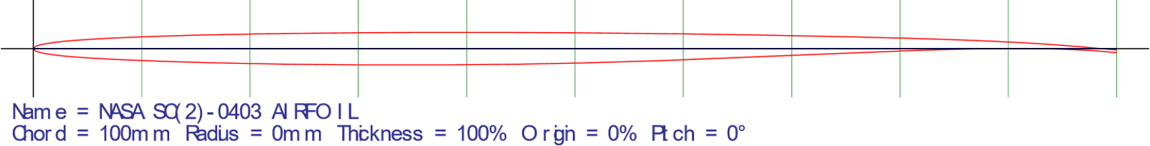

Figure : Wing Root Airfoil Profile

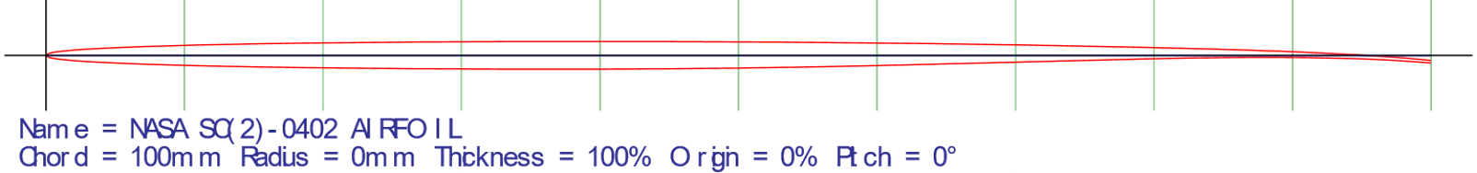

Figure : Wing Tip Airfoil Profile

The airfoils chosen are experimental NASA supercritical airfoils for which there exists a large amount of data. The airfoils vary in thickness from 3% at the root to 2% at the tip, chosen specifically to create additional space for fuel and structural considerations. A minimum thickness of 2% throughout the wing would have been ideal considering only wave drag, but it was determined through experimentation that additional fuel storage was necessary, and thus it was ultimately chosen to accept a larger wave drag penalty to incorporate this design.

The final wing configuration chosen was a double delta wing, designed to take advantage of vortex lift at subsonic speeds, notably at takeoff and landing, while still being optimized for supersonic flight. The initial sweep angle is $75°$, satisfying the previously determined sweep angle requirement to avoid the Mach cone effects. Additionally, this high sweep angle results in increased vortex lift due to increased flow separation across the leading edge under subsonic conditions. The secondary sweep angle is $48°$- this maximizes wing area for lifting surfaces and lift generation while retaining high aesthetic appeal. The aspect ratio was kept to a minimum, at 1.95, for alleviation of internal structural effects as well as maneuverability (Table XVI).

Figure . Project Morpheus Wing Planform

Table : Project Morpheus Wing Planform Characteristics

|  |  |  |
| --- | --- | --- |
| Aspect Ratio | Primary Sweep Angle (deg) | Secondary Sweep Angle (deg) |
| $$1.95$$ | $$75$$ | $$48$$ |

# Materials Selection & Structural Layout

The materials chosen for the Project Morpheus aircraft needed to be lightweight, strong, and heat resistant. One of the main reasons why a supersonic transport is more feasible today than it was when the Concorde was originally designed is that there have been numerous advancements made in composite materials. Carbon fiber-reinforced composites can be manufactured such that more complex aerodynamic shapes are easier to achieve. Additionally, their mechanical properties are much better than those of traditional aircraft-grade aluminum while maintaining lower weight. Since surface temperatures can reach upwards of 100º C, materials with a low coefficient of thermal expansion (CTE) were required (Heritage Concorde).

Taking inspiration from the composite designs of the Boeing 787 and Airbus A350, the Project Morpheus aircraft was designed to be mostly made of composite materials. The nose cone was made using E-glass fiber-reinforced epoxy to allow for radio communications and antennas to work properly. Most of the fuselage and wings were made of carbon fiber-reinforced epoxy composites. Steel and titanium were used for the engine attachment points and landing gear. Control surfaces and all leading edges for the wings, vertical tail, and engine nacelles were made of titanium due to its low weight, low CTE, and better impact performance than carbon composites.

The structural layout was developed using references from the Concorde and the Boeing 787. A semi-monocoque structure was developed for the wing. The carbon fibers in the skin were oriented such that they could carry some bending loads without the need for a large internal structure. For the internal structure of the wing, a carbon composite box assembly was used, following the example of the Boeing 787. Three spars and 12 carbon composite ribs were used per wing to carry the remaining loads in the aircraft, with steel reinforcement along the engine attachment points for added rigidity. This allowed for the greatest internal volume while still maintaining good mechanical performance. The wing structure can be seen in Figure 20 below. In the figure, spars are highlighted in green and blue, while the ribs are highlighted in purple and red for the two sections of the wing.

Figure . Wing structural layout for Project Morpheus aircraft.

The tail structure was developed similar to the wing structure. Two spars and five composite ribs were used to support the vertical wing. This can be seen in Figure 21 below. Ribs are highlighted in cyan, while the spars are highlighted in yellow. The dark blue highlight corresponds to the rudder control surface.

Figure . Tail structural layout for Project Morpheus aircraft.

Finally, the fuselage structure was developed as a monocoque structure. Since fibers can be oriented to carry longitudinal and hoop stresses in the fuselage, stringers and longerons are not needed for this design. Instead, formers along the length of the fuselage provide axial reinforcement to the skin, which carries the remaining loads. These formers can be seen in Figure 22 below. Here, the formers are highlighted in light blue and the skin is shown as a wireframe in magenta. A cross-sectional view of the fuselage structure can also be seen in Figure 23 below. All measurements are in ft.

Figure . Fuselage structural layout for Project Morpheus aircraft.

Figure . Cross-sectional view of Project Morpheus Aircraft.

The flight deck will have seats for two crew – the Captain and the First Officer – along with a third “jumpseat” immediately behind the two for observation. The aircraft utilizes existing commercial avionics for seamless integration with the airspace systems found around the world. Specifically, Project Morpheus will partner with Honeywell Aerospace to integrate the Primus Epic avionics line into production aircraft. All primary flight displays, engine indication systems, and navigation systems will be forward-mounted for direct pilot line-of-sight. Project Morpheus intends to offer the option to purchase heads-up displays (HUDs) for pilot convenience in poor instrument conditions.

Touchscreen technology will allow for unparalleled convenience and ease-of-access to critical flight systems on the overhead panel as well as the forward center pedestal. All four throttles will be located on the middle center pedestal, in between the two pilots, with additional secondary controls located just aft of the throttles. Honeywell’s SmartView Synthetic Vision will provide a full three-dimensional image of the outside world to enhance safety and efficiency during takeoff and landing.

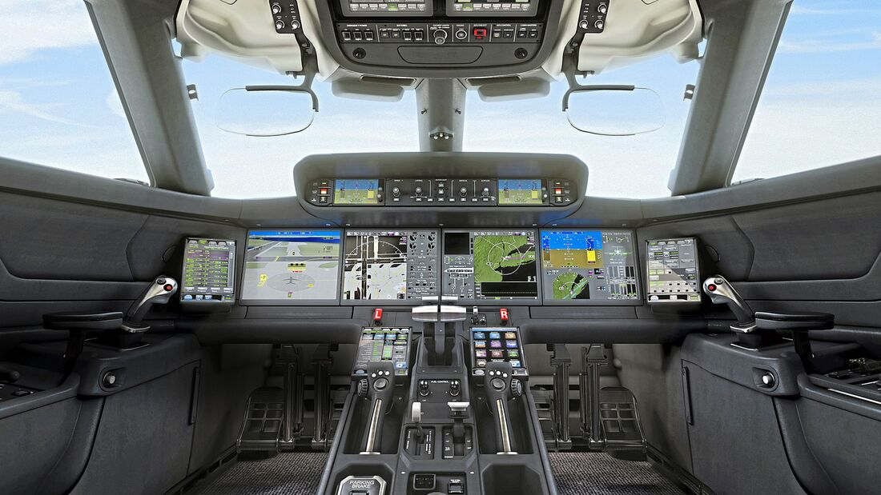

Figure . Primus Epic integrated flight deck on a long-range business jet.

# Moments of Inertia and Center of Gravity Analysis

Historical data on the moments of inertia (MOI) of the NAA A3J-1 supersonic cruise aircraft (Roskam) will allow an estimate to be calculated for the MOI of Project Morpheus using the radius of gyration calculations given in the table below. The value for *e* given in the table is defined by Equation 18 below, where *b* is the wingspan and *L* is the total length of the aircraft.

Table . Radii of gyration calculation for NAA A3J-1 (Roskam).

|  |  |  |  |  |  |  |  |
| --- | --- | --- | --- | --- | --- | --- | --- |
| Aircraft | Gross Weight | b | L | e | $$\overline{R_{x}}$$ | $$\overline{R_{y}}$$ | $$\overline{R_{z}}$$ |
| Units | lb | ft | ft | ft | ~ | ~ | ~ |
| NAA A3J-1 | 44305 | 53 | 72.5 | 62.8 | 0.24 | 0.372 | 0.472 |

The $\overline{R_{x}}, \overline{R_{y}}, and \overline{R_{z}}$ values are the radii of gyration about each axis and can be used in the system shown in Equation 19 below to calculate the MOI of Project Morpheus (see table below).

$\begin{aligned}&I_{xx}=\frac{b^{2}W{\left({\overline{R}}_{x}\right)}^{2}}{4g} \\ &I_{yy}=\frac{L^{2}W{\left({\overline{R}}_{y}\right)}^{2}}{4g} \\ &I_{zz}=\frac{e^{2}W{\left({\overline{R}}_{z}\right)}^{2}}{4g}\end{aligned}$ (19)

|  |  |  |  |  |  |  |  |
| --- | --- | --- | --- | --- | --- | --- | --- |
| Aircraft | Gross Weight | b | L | e | $$I_{xx}$$ | $$I_{yy}$$ | $$I_{zz}$$ |
| Units | lb | ft | ft | ft | slug-ft2 | slug-ft2 | slug-ft2 |
| Project Morpheus | 195149.3 | 58.82 | 160 | 109.4 | 301,900 | 5,367,600 | 4,040,500 |

To begin the center of gravity analysis of the aircraft, a breakdown of the individual component weight must be developed based on historical data. Using weight breakdowns of supersonic cruise aircraft data (Roskam), an average weight fraction for each component was calculated relative to its gross weight as seen in Table XVIII.

Table . Average component weight fractions from three historic supersonic cruise aircraft.

|  |  |  |  |  |
| --- | --- | --- | --- | --- |
| Aircraft | AST-100 | SSXJET | Super-cruiser | Average |
| Gross Weight (lb) | 718,000 | 35,720 | 37,144 | 263,621 |
| Wing/GW | 0.12 | 0.101 | 0.107 | 0.109 |
| Empenn/GW | 0.015 | 0.013 | 0.006 | 0.011 |
| Fuse/GW | 0.073 | 0.098 | 0.059 | 0.077 |
| Nacelle/GW | 0.023 | 0.014 | 0.019 | 0.019 |
| Landing Gear/GW | 0.038 | 0.039 | 0.035 | 0.037 |
| Propulsion/GW | 0.083 | 0.104 | 0.182 | 0.123 |
| Fixed Equip/GW | 0.083 | 0.078 | 0.121 | 0.094 |

With these average component weight fractions, estimated values for Project Morpheus can be found in Table XIXXIX below. Some minor adjustments were necessary to account for rounding errors so that the total of all weights added up to the correct gross weight.

Table XIX. Corrected component weight estimations based on historical averages.

|  |  |
| --- | --- |
| Component | Estimated Weight (lb) |
| Wing | 19,924.9 |
| Empennage | 2065.4 |
| Fuselage | 13,971.7 |
| Nacelles | 3401.8 |
| Landing Gear | 6803.6 |
| Power Plant | 22,415.5 |
| Fixed Eqp. | 17,130.6 |
| Empty | 85,713.5 |
| Crew | 1380.0 |
| Operating Empty | 87,093.5 |
| Payload | 11,500 |
| Fuel | 96,555.7 |
| Gross Weight | 195,149.3 |

Now that component weights have been established, the center of gravity calculations for each can commence. Using the Open Vehicle Sketch Pad (OpenVSP) application developed by NASA, a model of the aircraft was constructed.

The origin of the model was about 2.5 feet above the nose tip, which is the arbitrary point that will be used to calculate the aircraft center of gravity about. The z-axis is oriented with up as positive, so therefore the nose tip is located at about z = -2.5 ft. The x-axis is oriented with towards the tail as positive with the nose tip at about x = 0 ft and the y-axis with right as positive and centered so the aircraft is symmetric about the y-axis (nose tip at y =0). The center of gravity of the aircraft is simply a weighted sum of components divided by the total weight of the aircraft. To write the longitudinal (x) center of gravity (CG) of all components *i* relative to an arbitrary origin *O*, Equation 20 can be utilized. The distance along the axis of interest (again, x in this case) between the CG of the component and the origin *O* is called a moment arm, expressed in Equation 20 as $x_{CG, i}$, while the weight of the individual component is shown as $W_{i}$. The sum of all aircraft component weights is equal to the total weight of the aircraft, or $W_{T}$, and the calculated position of the overall center of gravity of the aircraft is expressed as $x_{CG, O}$.

$$\begin{aligned}x_{CG,O}= \sum_{i=1}^{i=n}{\frac{x_{CG,i}W_{i}}{W_{T}}} \#\left(20\right)\end{aligned}$$

The same equation can also be applied to the z axis to find the vertical center of gravity, which will be useful later in calculating the landing gear tipover angles. The guidance given in Roskam to estimate the moment arms of the components’ individual CG locations relative to key component locations like the leading edge of the root chord, front of nacelle, etc. was followed. Estimated x and z moment arms from the origin *O*, component weights, and the various total CGs can be found below in Table XXXX for the Project Morpheus aircraft. The operating empty CG includes all the components in the empty weight CG but with the addition of the crew CG. The gross weight CG includes everything in the operating empty CG but with the inclusion of the payload and fuel components.

Table XX. Component and vehicle center of gravity estimations.

|  |  |  |  |  |
| --- | --- | --- | --- | --- |
| Center of Gravity | Component | X Location (ft) | Z Location (ft) | Weight (lb) |
| Empty Weight CG | **Empty Weight** | **98.5** | **-1.27** | **85713.5** |
| Wing | 113.1 | -1.3 | 19924.9 |
| Empennage | 142.2 | 8.5 | 2065.4 |
| Fuselage | 72.0 | 0.0 | 13971.7 |
| Nacelles | 110.0 | -3.0 | 3401.8 |
| Nose Gear | 60.0 | -3.9 | 680.4 |
| Main Gear | 109.5 | -6.3 | 6123.3 |
| Power Plant | 114.0 | -3.0 | 22415.5 |
| Fixed Eqp. | 73.0 | 1.0 | 17130.6 |
| Operating Empty CG | **Operating Weight** | **97.6** | **-1.23** | **87093.5** |
| Crew | 40.0 | 1.0 | 1380.0 |
| Gross Weight CG | **Gross Weight** | **105.5** | **-0.34** | **195149.3** |
| Payload | 85.8 | 1.0 | 11500.0 |
| Fuel | 115.0 | 0.3 | 96555.7 |

The OpenVSP model of the aircraft was exported to SolidWorks as a step (.stp) file and then then turned into a SolidWorks part. Using SolidWorks, the estimated positions of the center of gravity of each component can be displayed and visually verified for logical sense. The table and accompanying figure below show these component locations on a side view of the aircraft.

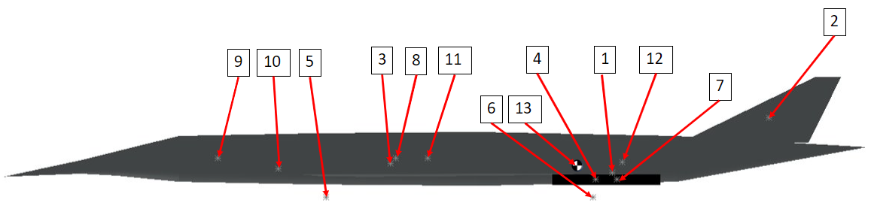Table . Number labels for the vehicle center of gravity visualization.

Figure . Vehicle center of gravity visualization

|  |  |
| --- | --- |
| **Number​** | **Component​** |
| 1​ | Wing​ |
| 2​ | Tail​ |
| 3​ | Fuselage​ |
| 4​ | Nacelles​ |
| 5​ | Nose Gear​ |
| 6​ | Main Gear​ |
| 7​ | Power Plant​ |
| 8​ | Fixed Equipment​ |
| 9​ | Crew​ |
| 10​ | Baggage​ |
| 11​ | Passengers​ |
| 12​ | Fuel​ |
| 13​ | Most Aft CG​ |

Overall geometries of the aircraft are shown below in the figure for the Project Morpheus aircraft, as well as the most aft CG.

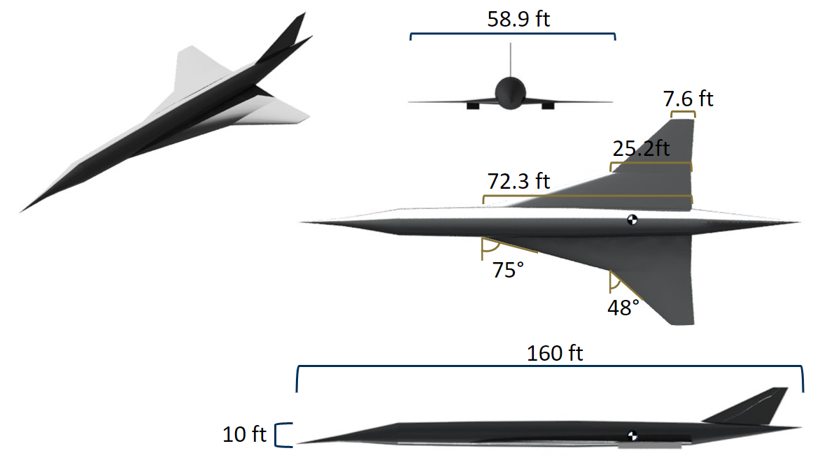

Figure : Overall geometry and three-view of Project Morpheus aircraft with most aft CG

Using the vehicle centers of gravity found previously, some additional CG calculations were made for operating empty weight with payload and with fuel. All these vehicle weights were combined into the table below, which is the CG envelope for the aircraft. The x-axis CG was also written as a percentage of the mean aerodynamic chord (MAC), which will be discussed further.

Table : Center of gravity envelope.

|  |  |  |  |  |  |
| --- | --- | --- | --- | --- | --- |
| Name | Weight (lb) | $x_{CG, O}$ (ft) | % MAC at Mach 0.95 | % MAC at Mach 2 | $z_{CG, O}$ (ft) |
| Empty Weight | 857134 | 98.51 | 21.55 | 29.68 | -1.27 |
| Operating Empty Weight | 87094 | 97.58 | 24.39 | 32.52 | -1.23 |
| Operating Empty Weight + Payload | 98594 | 96.21 | 28.60 | 36.73 | -0.97 |
| Takeoff Gross Weight | 195149 | 105.51 | 0.07 | 8.20 | -0.34 |
| Operating Empty Weight + Fuel | 183649 | 106.74 | -3.71 | 4.42 | -0.43 |

The MAC is an important value used in stability calculations, as the static stability margin is often written in terms of it. The length of the MAC was found using OpenVSP and can be located on the aircraft by finding the y-position on the wing where the chord matches the MAC length. The next step to find the static margin is to locate the neutral point on the MAC. The x-position of the neutral point (NP) – also known as the aerodynamic center – changes based on Mach number. It was found for the subsonic Mach 0.95 and supersonic Mach 2 cruise conditions by running a stability analysis in VSPAero at those flight speeds. From here, the static margin can be calculated according to Equation 21 below, which uses the most aft CG. The static margin is the difference between the CG location and the neutral point, as expressed in terms of the MAC length.

$$\begin{aligned}Static margin=\frac{x_{CG,O}-x_{NP}}{MAC} \#\left(21\right)\end{aligned}$$

The results of this stability analysis are included in the table below for the most aft CG.

Table : Neutral point and mean aerodynamic chord locations.

|  |  |  |  |  |
| --- | --- | --- | --- | --- |
| Flight Speed (Mach) | MAC Length (ft) | X-location of Leading Edge of MAC (ft) | X-location of NP (ft) | Static Margin |
| 0.95 | 32.590 | 86.62 | 105.53 | -3.71 |
| 2 | 108.18 | 4.42 |

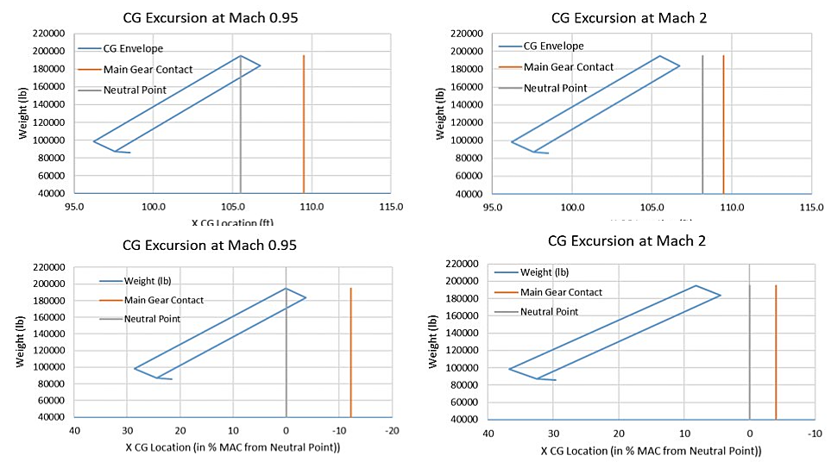The center of gravity envelope can be hence plotted for two speeds and against two different x-axes: distance in feet or distance in terms of the MAC. See the figure below for these CG excursion plots.

Figure : CG Excursions for Mach 0.95(left) and Mach 2(right).

**Landing Gear and Fuel Tanks**

The landing gear and strut lengths were sized according to the dimensions given in the table below. All dimensions and locations are given in feet. Tires found that would match the dimensions and weight requirements are the *Goodyear 21x7.25-10* for the nose gear and the *Goodyear H44.5x16.5-21* for the main gear (Goodyear Aviation).

Table : Landing gear details

|  |  |  |  |  |  |  |  |  |  |
| --- | --- | --- | --- | --- | --- | --- | --- | --- | --- |
| Gear | Strut length | xCG | yCG | zCG | Number of main gear struts | Number of wheels per strut | Weight per wheel | Diameter | Total height |
| Main | 8.645833 | 109.5 | 10 | -6.25 | 2 | 2 | 46066 | 3.71 | 10.5 |
| Nose | 7.864583 | 60 | 0 | -3.93229 | 1 | 1 | 10885 | 1.77 | 8.75 |

To ensure the aircraft can take off and land adequately or travel on the ground without striking other parts of the vehicle, landing gear tipover and clearance metrics must be verified to meet operational standards. The first is to ensure the aircraft does not have too much or too little weight on the nose gear (NG) and the main gear (MG), as this would cause problems at takeoff and landing if not in-range. The required and actual weight distribution for each gear as a percentage of the maximum CG are included in the table below. As shown below, the load distribution between the gears falls within the acceptable range.

Table : Load distribution on the main and nose gears as a percentage of maximum weight

|  |  |  |
| --- | --- | --- |
|  | Load on NG | Load on MG |
| Actual | 5.58 % | 94.42 % |
| Required Range | 5 – 15 % | 85 – 95 % |

The rest of the landing gear metrics and their requirements are shown in the table below. All clearance and tipover angle requirements are satisfied by the current placement of the aft CG and landing gear.

Table : Landing gear clearance and tipover angles

|  |  |  |  |  |
| --- | --- | --- | --- | --- |
| Metric | Longitudinal Tipover | Lateral Tipover | Longitudinal Ground Clearance | Lateral Ground Clearance |
| Actual | 13.83 deg | 51.93 deg | 16.76 deg | 24.32 deg |
| Required Range | < 15 deg | < 55 deg | > 15 deg | > 5 deg |

The fuel tanks for this aircraft are concentrated around the CG to assist with balanced fuel depletion. The fuselage and tail cone tanks will hold the majority of the fuel because of the thinness of the wings, which are only thick enough at the highly swept portion of the wing to hold an appreciable amount of fuel. An area of future development for this aircraft would be to find out if the allotted volume would be enough to hold the amount of fuel required and if the fuel CG is realistic to keep so far aft. If more fuel room is needed, extending the fuselage aft of the wing to hold more fuel and bring the CG further aft is one of the first options to explore.

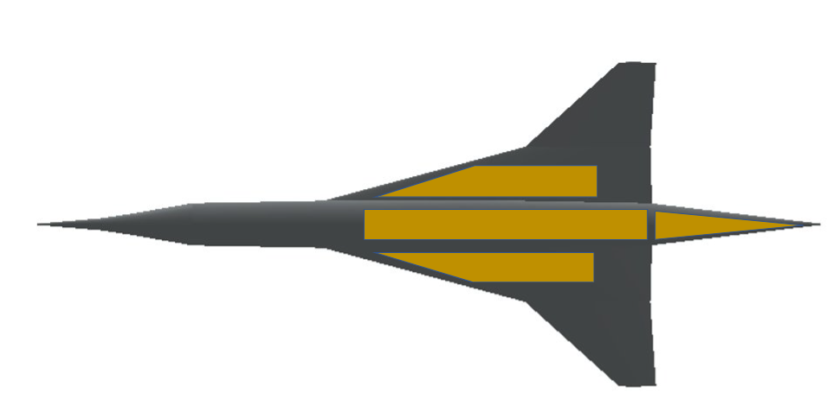

Figure : Fuel Tank Locations

# Stability Analysis & Control Surface Sizing

A crucial requirement for the aircraft is that it be stable. Therefore, a stability analysis was performed to ensure that the aircraft was statically stable. Dynamic stability was not evaluated in this preliminary analysis as instability can be corrected via software or pilot input in later stages of the design. Within static stability, the static margin and three main stability derivatives were determined.

The three primary requirements for static stability involve the $C_{m,α}$, $C_{l,β}$**,** and $C_{n,β}$ stability derivatives. The coefficients $C_{l}$, $C_{m}$, and $C_{n}$ are defined as the roll, pitch, and yaw moment constants, respectively. These are non-dimensional constants relating to the roll, pitch, and yaw moments for the aircraft. The stability derivatives $C_{m,α}$, $C_{l,β}$**,** and $C_{n,β}$ were determined by taking the derivative of the pitch constant with respect to the angle of attack; the derivative of the roll constant with respect to the angle of sideslip; and the derivative of the yaw constant with respect to sideslip; respectively. In order to maintain static stability, $C_{m,α}$ and $C_{l,β}$ needed to be negative while $C_{n,β}$ needed to be positive.

A computational approach was taken to determine these static stability derivatives. A CAD model of the aircraft was generated in VSP software. Using VSP Aero software, the roll, pitch, and yaw moment coefficients could be calculated at a specific angle of attack and angle of sideslip. In order to determine the stability derivatives, the roll, pitch, and yaw coefficients were calculated over different angles of attack and sideslip. When these were calculated, the respective parameters for each stability derivative were plotted against their respective angle. A curve fit of the data resulted in the stability derivative. Calculations were performed for subsonic and supersonic cruise segments, where the aircraft’s stability was most relevant.

The longitudinal stability derivative was $C_{m,α}$. It was calculated using the previously stated methodology, with the resulting plots shown below. The curve fit resulted in a subsonic cruise $C_{m,α}$ of -1.98 /rad, meaning that the aircraft would respond to a positive pitch moment with a negative moment, returning to the equilibrium state, as was necessary. Likewise, for supersonic cruise, the $C_{m,α}$ was -1.71 /rad. The curves for each can be seen in Figure 2929 and Figure 3030 below. Each curve plots the relationship between the pitch moment coefficient and the angle of attack of the aircraft. These calculations were performed assuming that there was no flow separation at higher angles of attack.

Figure 29. Numerical determination of subsonic cruise for Project Morpheus aircraft.

Figure 30. Numerical determination of supersonic cruise $C_{m,α}$ for Project Morpheus aircraft.

The first lateral-directional stability derivatives depended on the angle of sideslip of the aircraft. These stability derivatives were determined the same was as $C_{m,α}$. For subsonic stability derivatives, $C_{n,β}$ was found to be 22.9 /rad while $C_{l,β}$ was found to be -0.16 /rad. The former number indicates that the aircraft was very stable about the yaw axis, but the latter quantity indicates that, while the aircraft was stable about the roll axis, it was not very stable. However, both quantities are in the expected directions, meaning that the aircraft was always stable in subsonic flight. The plots for each calculation can be seen in Figure 3131. While there was some variation in the data, the stability derivatives depended on the slope of the resulting curves. This slope did not change much between each curve, meaning that the stability derivatives did not have much variation.

Figure 31. Numerical determination of subsonic cruise and for Project Morpheus aircraft.

Figure 32. Numerical determination of supersonic cruise $C_{n,β}$ and $C_{l,β}$ for Project Morpheus aircraft.

The supersonic lateral-directional stability derivatives were determined in the same way as the subsonic ones. This analysis yielded similar results to those in the subsonic analysis. The value for $C_{n,β}$ was 25.8 /rad, somewhat higher than the subsonic value. This means that the aircraft is more stable to changes in yawing moments. The supersonic value of $C_{l,β}$ was -0.17 /rad, basically the same value as for subsonic flight. However, as with subsonic performance, this means that the aircraft was statically stable for both subsonic and supersonic cruise segments. The plots used to calculate these numbers can be seen in Figure 3232. All stability derivatives can be seen in Table XXIIIXXVII below.

Table XXIII. Static stability derivatives for Project Morpheus aircraft.

|  |  |  |
| --- | --- | --- |
| Stability Derivative | Subsonic Cruise (/rad) | Supersonic Cruise (/rad) |
| $$C_{m,α}$$ | -1.98 | -1.71 |
| $$C_{n,β}$$ | 22.9 | 25.8 |
| $$C_{l,β}$$ | -0.16 | -0.17 |

Following static stability analysis, the dimensions for the control surfaces of the aircraft could be determined. Since Project Morpheus does not have a horizontal tail, the two types of control surfaces are elevons and a rudder. Slats were also used in the leading edges of the wing to increase the lift for the approach and landing segments of the mission profile. No flaps were used since they would have led the wing to stall at the required angle of attack for landing.

Figure 33. Wing control surfaces for Project Morpheus Aircraft.

Figure 3333 displays the control surfaces on the wing of the Project Morpheus aircraft. The green and blue highlights depict the leading-edge slats, while the yellow highlights the aircraft’s elevons. The elevon area was determined using the Concorde as an example per the methodology outlined by Roskam. This number was chosen to be 300 ft2 divided between the two elevons. Since the roll stability derivatives were somewhat low, having the elevons be as far away from the fuselage was necessary to increase their moment arm. This would allow for better controllability and a better response to a pilot input.

The rudder area was determined the same way as the elevon area. It can be seen in Figure 3434 below. It was set to be 80 ft2. Yaw controllability was not as important for this aircraft as for conventional twinjets since it features four engines. Therefore, if one engine is inoperative, it has to overcome less of a total yawing moment due to propulsive yaw moment.

Figure 34. Vertical tail control surface for Project Morpheus aircraft.

# Propulsion System

Per the RFP, the Project Morpheus aircraft was to be developed using near-term technology. Several engine designs were considered, including current military engines and past supersonic engines like the Rolls-Royce Olympus used in the Concorde. While the Olympus had good performance and efficiency at Mach 2, noise regulations at airports like London Heathrow would not allow for a turbojet engine. Therefore, the low-bypass General Electric Affinity engine was chosen since it would allow for the best performance while still maintaining high efficiency and low emissions.

The Affinity engine was originally developed for the Aerion supersonic jet until the company collapsed. Even though development for that engine ceased, it was assumed that, by 2030, it could be ready for use for the Project Morpheus aircraft. It is also based on the ore of the CFM56, the most widely used engine type in the world. This means that GE is already familiar with a lot of the design, resulting in less development time needed to finalize the design for Project Morpheus. The Affinity is rated at a maximum of 21,000 lbs of thrust at sea level without the need for afterburning. It has a fan diameter of 52 in and a bypass ratio of ~3. It is 11.2 ft long and weighs ~5,600 lbs without nacelles or thrust reversers (Leeham News).

Since this engine has not been tested yet, it was difficult to provide performance numbers beyond an expected thrust at sea level. Therefore, as stated in the Weight Sizing section, different engine performance characteristics were used with a conservative propulsive efficiency factor to account for technology gains that would be made as a result of the development of the engine.

# Cabin Layout

The layout of the Morpheus Project was designed with the comfort, practicality, and cost-benefit of passengers in mind. The aircraft features one aisle, one seat on each side of the aisle, and 25 rows, for a total of 50 passengers. The seat pitch will be offered at 38 inches, a recline of 8 inches, a width of 9 inches, and a raisable leg rest. The comfort of this seat will be supplemented by a sliding plastic door for increased privacy, if desired. Lie-flat seats were not selected for the Morpheus Project due to the lack of necessity. The maximum flight length on the aircraft would be no more than four hours; thus, comfortable first class-style seats were selected to optimize both seating density and passenger comfort. Figure 35, below, shows a sketch of the proposed cabin configuration.

Figure 3535. Proposed cabin layout.

The airplane features four Type C emergency exits as mandated by 14 CFR 25.807. These are boxed in red and are located by the forward and aft galleys. For the required crew, the aircraft features two pilot seats, two flight attendant jumpseats, and one extra jumpseat in the flight deck.

# Cost Analysis

Unlike military or government applications, civil aviation inherently requires a positive return-on-investment for continuous operation. A rigorous cost analysis was performed on the proposed Project Morpheus aircraft to ensure that all possible economic factors are taken into consideration. The primary goal of this analysis was to arrive at a cost for the production of 200 production airframes and three test aircraft. Cost estimating relationships (CERs) based on the Nicolai and Carichner model were modified and used for this analysis. Two categories of CERs were defined: non-recurring and recurring costs. Several elements within these categories were measured in terms of hours. As the Nicolai model provides hourly rates in 2012 dollars, these were adjusted to 2022 dollars as shown in Table XXIVXXVIII below, at a rate of 1.2351 2022-to-2012 dollar. CERs evaluated for this project were airframe engineering, development support, flight test operations, tooling, manufacturing labor, quality control, and manufacturing materials & equipment. Engine and avionics costs were assumed to be off-the-shelf items and thus were not calculated for this proposal.

|  |  |  |
| --- | --- | --- |
| Category | 2012 USD | 2022 USD |
| Engineering ( $R_{E})$ | $115 | $142.04 |
| Tooling $(R_{T})$ | $118 | $145.74 |
| Quality Control $(R_{Q})$ | $108 | $133.39 |
| Manufacturing $(R_{M})$ | $98 | $121.04 |

Table XXIVXXVIII. Hourly labor rates used in cost analysis for Project Morpheus aircraft.

Cost of production was calculated for a range of production quantities; production was considered from 10 to 400 airframes. All calculations assumed a test fleet size of three aircraft, adding these three additional aircraft to the final model. The Nicolai models as shown in the equations below reference several key variables from the aircraft design process. *W* represents the empty weight of the aircraft. *S* represents the maximum speed of the aircraft at cruise altitude, using the 55,000 ft altitude resulting from the constraint analysis trade study. *Q* is the cumulative number of airframes produced. $Q_{D}$, used in the flight test operations equation, excludes all production aircraft and instead refers to all airframes used for testing and certification. Equations 19 through 25, respectively, represent: airframe engineering hours, development support cost, flight test operations cost, tooling hours, manufacturing hours, quality control hours, and manufacturing material & equipment cost. The Nicolai model provides “cost” in 1998 or 1999 dollars; these were appropriately converted at a rate of 1.7023 1999-to-2022 dollars and 1.7396 1998-to-2022 dollars.

$$\begin{aligned}E=4.86W^{0.777}S^{0.894}Q^{0.163}\#\left(19\right)\end{aligned}$$

$$\begin{aligned}D=66W^{0.63}S^{1.3}\#\left(20\right)\end{aligned}$$

$$\begin{aligned}F=1852W^{0.325}S^{0.822}Q_{D}^{1.21}\#\left(21\right)\end{aligned}$$

$$\begin{aligned}T=5.99W^{0.777}S^{0.696}Q^{0.263}\#\left(22\right)\end{aligned}$$

$$\begin{aligned}L=7.37W^{0.82}S^{0.484}Q^{0.641}\#\left(23\right)\end{aligned}$$

$$\begin{aligned}QC=0.076L\#\left(24\right)\end{aligned}$$

$$\begin{aligned}M=16.39W^{0.921}S^{0.621}Q^{0.799}\#\left(25\right)\end{aligned}$$

As expected, unit costs of the proposed aircraft were extremely high below 50 production aircraft. However, the cost-per-aircraft tapered off relatively quickly and became viable at approximately 200 aircraft produced. Figure 36. Relationship between unit cost and aircraft produced (no engines included).demonstrates this exponential decay relationship between unit cost and the number of aircraft produced. For the requested fleet size of 200 aircraft, the unit flyaway cost is approximately $190.2 million USD assuming operators purchase four GE Affinity engines per aircraft, valued at $15 million per engine. This is a highly competitive price point, as similar long-range aircraft cost several hundreds of millions of dollars. Marketing the Project Morpheus aircraft at $210 million will lead to at least a 10% profit for a 200 plane fleet size, progressively growing as more airplanes are bought.

Figure 36. Relationship between unit cost and aircraft produced (no engines included).

An analysis into hourly operating costs was also conducted. There were three formulae used to calculate these factors. The crew cost was calculated based on cruise velocity in knots and gross takeoff weight in pounds:

$$\begin{aligned}crew cost=51{\left(V_{c}\frac{W_{o}}{{10}^{5}}\right)}^{0.3}+122 \#\left(26\right)\end{aligned}$$

This provided a crew cost of $562.93 per hour, adjusted to 2022 dollars as $973.87 per hour. Next, maintenance costs per hour and additional costs per cycle were calculated with the following two formulae. In the below formulae, $C_{a}$ is the cost of one aircraft less the engine cost, $C_{e}$ is the cost of one aircraft including engines, and $N_{E}$ is the number of engines (in this case, four).

$$\begin{aligned}\frac{MC}{FH}= 3.3\left(\frac{C_{a}}{{10}^{6}}\right)+10.2+\left[58\left(\frac{C_{e}}{{10}^{6}}\right)-19\right]N_{E} \#\left(27\right)\end{aligned}$$

$$\begin{aligned}\frac{MC}{cycle}= 4\left(\frac{C_{a}}{{10}^{6}}\right)+6.7+\left[7.5\left(\frac{C_{e}}{{10}^{6}}\right)+4.1\right]N_{E}\#\left(28\right)\end{aligned}$$

The material cost per flight hour was found to be $52,821 in 2022 dollars, with an additional $7,597 per flight cycle. The fuel burn was estimated by dividing an average mission duration (3.5 hours) by the fuel burned to complete the mission (96,072 pounds or 14,318 gallons), producing an hourly fuel burn of 4,091 gallons per hour. With an average Jet A price of $7 per gallon, the hourly fuel cost is $28,636. Oil, brakes, and other consumables were estimated to cost 2% of fuel burn, or $573 per hour. By summing these values overall hourly operating cost of the Morpheus Project aircraft is estimated to be $84,200. This number will be easily offset by the sale of 10 to 15 round-trip tickets, depending on airline pricing strategy.

# Concluding Remarks

Supersonic airliners like the Concorde have not seen operation in decades. The technology available at the time was not robust enough to allow for efficient operation. However, with new and emerging technologies in the aerospace industry, a supersonic airliner could once again prove to be a possibility for business passengers. Therefore, per the requirements in the RFP, Project Morpheus seeks to fill the in the market void generated by the retirement of the Concorde in 2003. The goals of this analysis were to obtain a representative size of the aircraft and cost to produce 200 airframes.

The first part of the analysis focused on weight and constraint sizing for aircraft. Initially following the requirements from the RFP resulted in weight and thrust values for the aircraft, but these were ultimately changed following trade studies. Out of the trade studies, the two that proved the most significant were the ones relating to the constraints caused by cruise elevation and takeoff field length. Consequently, the new values evaluated in these trade studies were adopted and used for subsequent calculations in the weight sizing and drag polar analyses. Therefore, the final weights of the aircraft for the standard and alternate missions were 171,300 and 183,000 lbs, respectively. The final thrust required by the aircraft was 82,000 lbs, with the ability to lower it based on the wing loading of the aircraft. The last part of the analysis involved performing a cost analysis to estimate the unit cost of each aircraft after building 200 airframes and three test aircraft. The final unit cost was found to be $190 million USD with four GE Affinity engines per aircraft.

These values were calculated for use only during preliminary analysis and ideation since no structural, control, or aerodynamic considerations were taken into account. However, they form a good baseline for what to expect from the aircraft pending further in-depth analysis. Overall, the goal of Project Morpheus was to provide supersonic travel to business passengers for trans-Atlantic journeys. The result of this analysis was a more accurate picture of what weight, thrust, and cost to expect once production of the aircraft begins.

# Works Cited

Aprovitola, Andrea, et al. "Aerodynamic Analysis of a Supersonic Transport Aircraft at Landing Speed Conditions." *Energies* 13 October 2021.

Buonnano, Michael. *A method for aircraft concept exploration using multicriteria interactive genetic algorithms*. PhD Thesis. Atlanta: August, 2005. Web.

Federal Aviation Administration. "Federal Aviation Regulations Title 14 Chapter I Subchapter C Part 25." Washington, DC: United States National Archives, 4 March 2022. Print.

*Fortune Business Insights*. n.d. Webpage. 17 March 2022. <https://www.fortunebusinessinsights.com/supersonic-jet-market-105715#:~:text=Boom%20Technology%20claims%20that%20the,delivering%20pre%2Dorders%20by%202030.>.

Goodyear Aviation. *The Aircraft Tire DataBook*. n.d. <https://www.goodyearaviation.com/resources/tiredatabook.html>.

Heritage Concorde. *Heritage Concorde*. n.d. 15 March 2022.

Honeywell. *Primus Epic for Gulfstream Symmetry*. n.d. 26 April 2022. <https://aerospace.honeywell.com/us/en/learn/products/cockpit-systems-and-displays/primus-epic-for-symmetry>.

*https://external-content.duckduckgo.com/iu/?u=https%3A%2F%2Fimgr1.flugrevue.de%2Fimage-169Gallery-690989af-1684834.jpg&f=1&nofb=1*. n.d.

Leeham News. "Bjorn's Corner: Supersonic Transport Revival, Part 12." *Leeham News and Analysis* 26 October 2019.

Mattingly, JD, W Heiser and G Daley. *Aircraft Engine Design*. Washington, DC: American Institute of Aeronautics and Astronautics, 1987. Print.

Mitsubishi Heavy Industries. "Production Technology of Large-Scale Composite Wings for Commerical Aircraft." *Mitsubishi Heavy Industries Technical Review* December 2014. Document.

Roskam, Jan. *Airplane Design Part 1: Preliminary Sizing of Airplanes*. Ottawa: Roskam Aviation and Engineering Corporation, 1985.

Sattler, Matthew. *On the market for a supersonic airliner*. 21 July 2021. Document. 17 March 2022. <https://matthewsattler.substack.com/p/on-the-market-for-an-supersonic-airliner?s=r>.

Sillers, Paul. *How soon will supersonic jets return to the skies?* 5 February 2020. Document. 17 March 2022. <https://www.cnn.com/travel/article/when-will-supersonic-flight-return/index.html>.

*U.S. Standard Atmosphere, 1976*. Report. Washington, DC: National Aeronautics and Space Administration, 1976. Document.

Witt, Alex. *Concorde: History and Development*. 10 August 2021. 4 April 2022. <https://ukaviation.news/concorde-history-development/>.